The IIE Varsity College

CLDV6211

Cloud Development A

ST10088532

POE

Aobakwe Kegoriloe

Due Date: 23 June 2025

Table of Contents

Part 1 3

Part 2 22

Part 3 41

Bibliography 57

# Part 1

ERD diagram

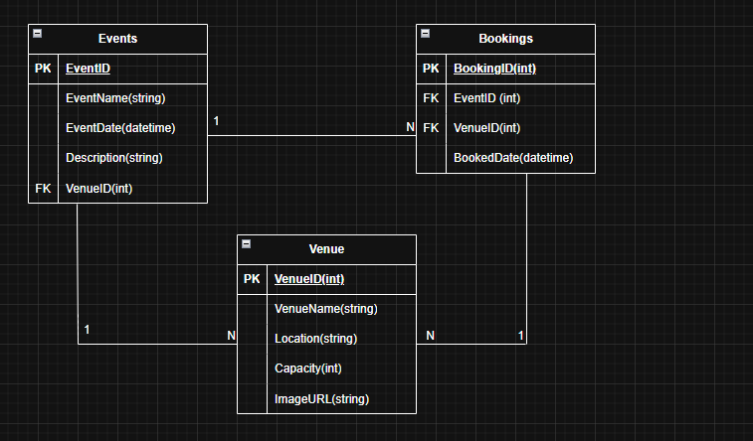

Screenshots of Web App

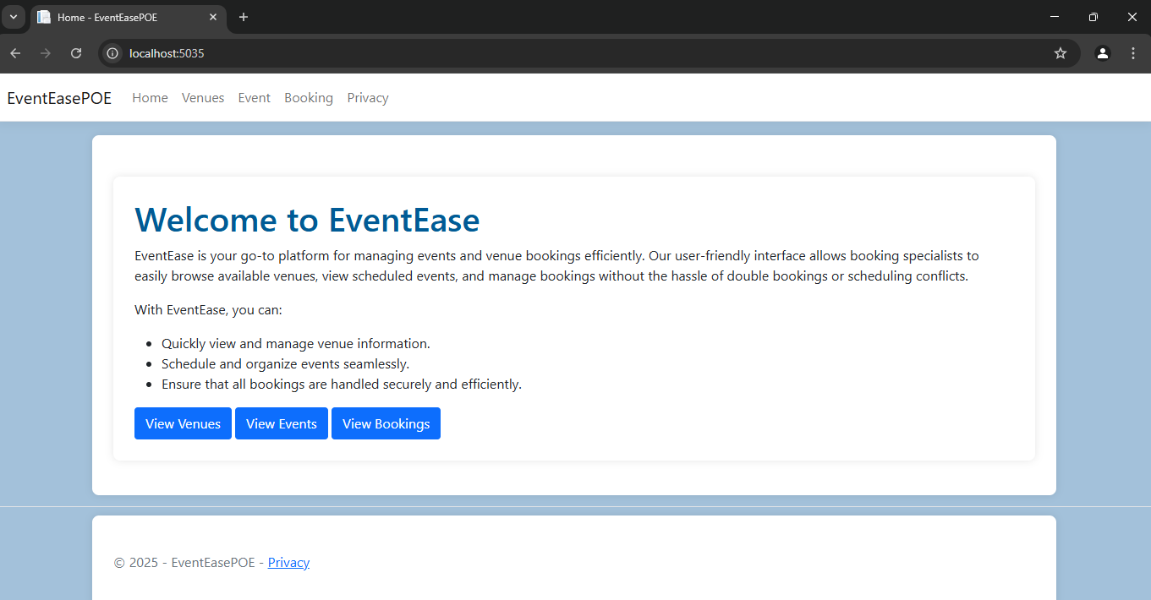

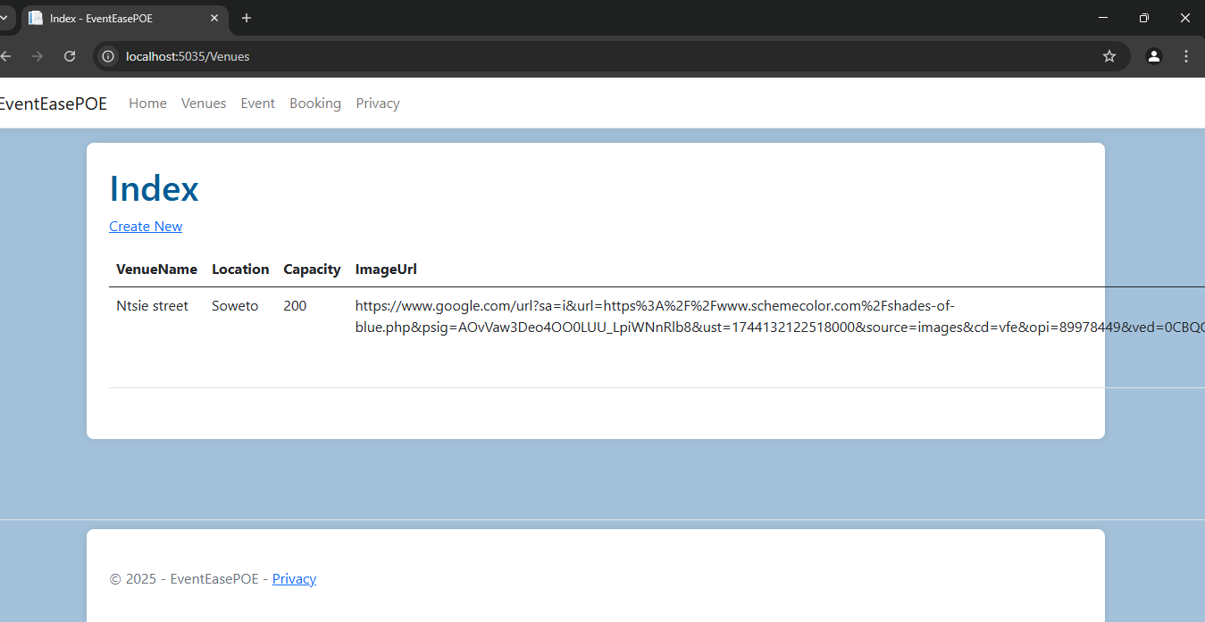

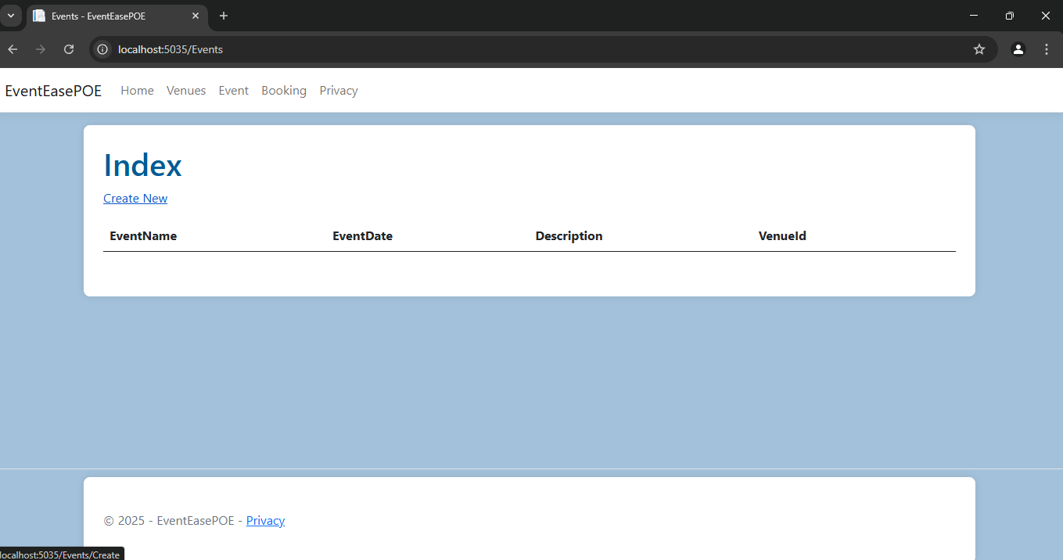

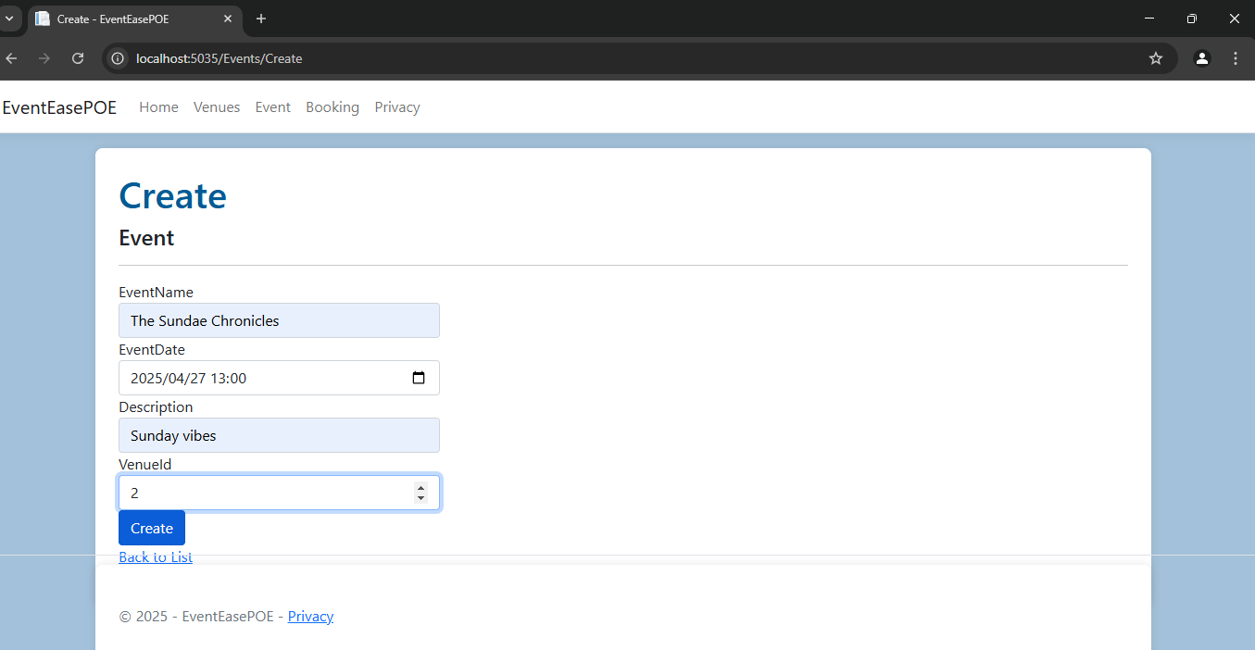

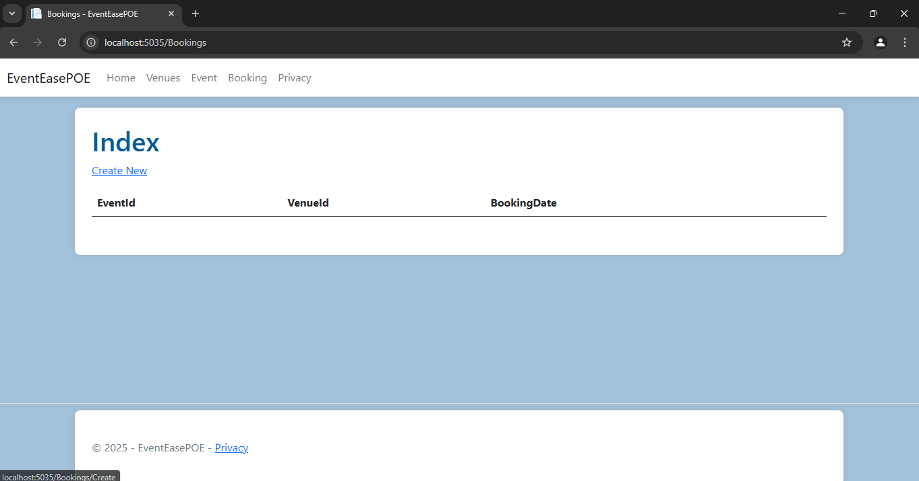

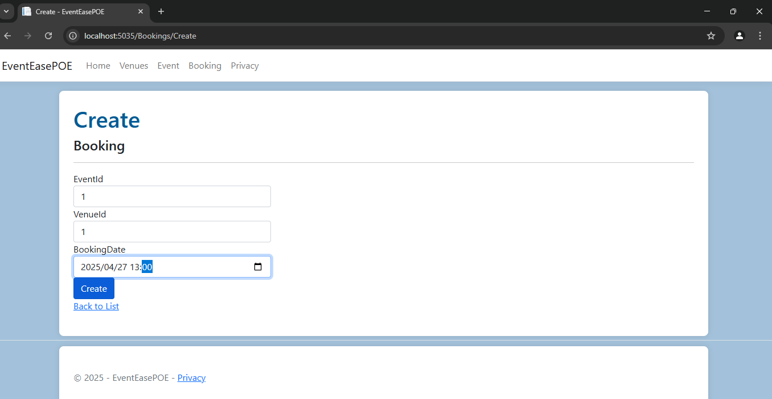

Visual Studio Code

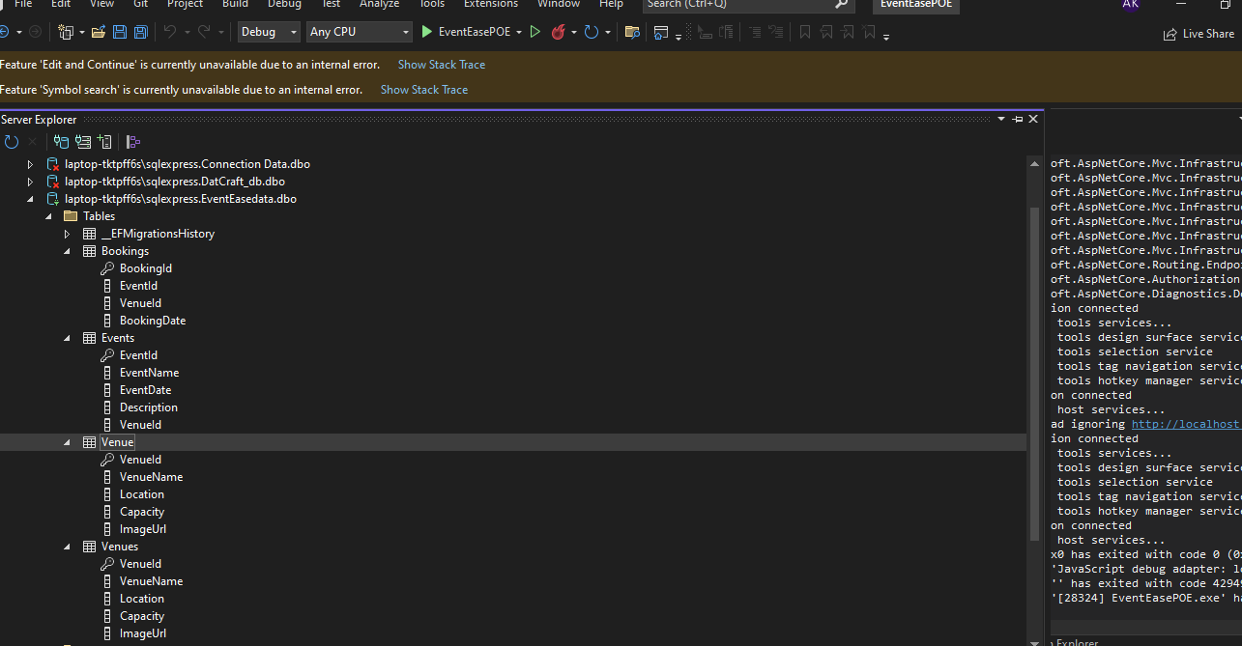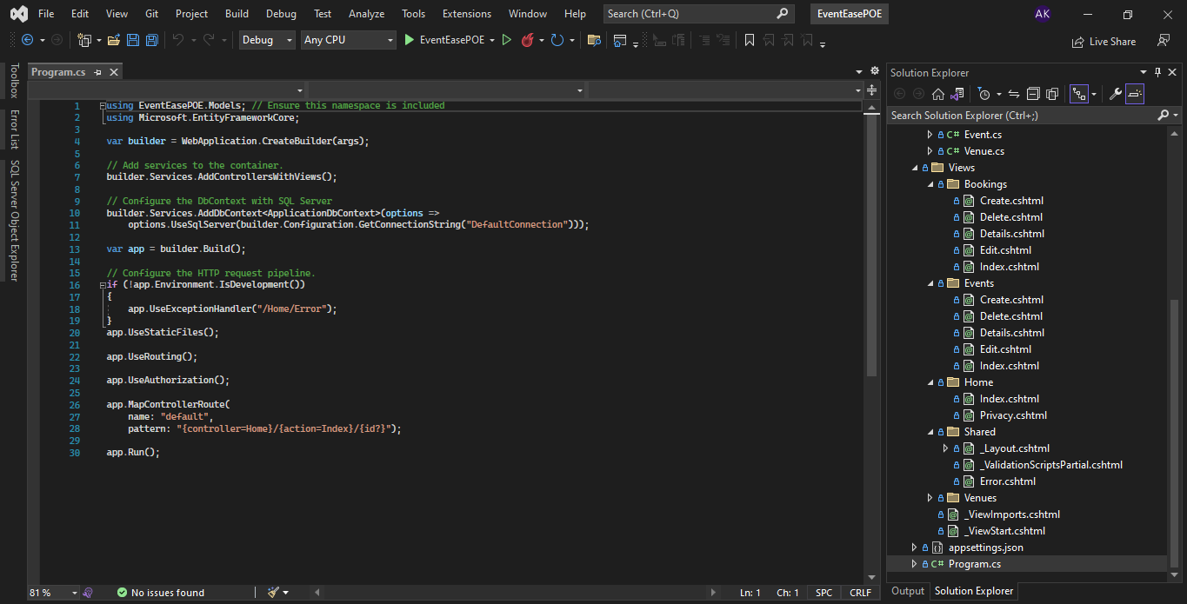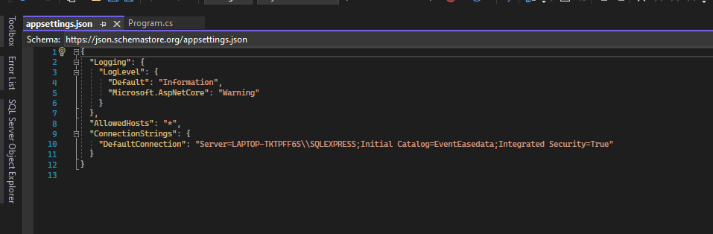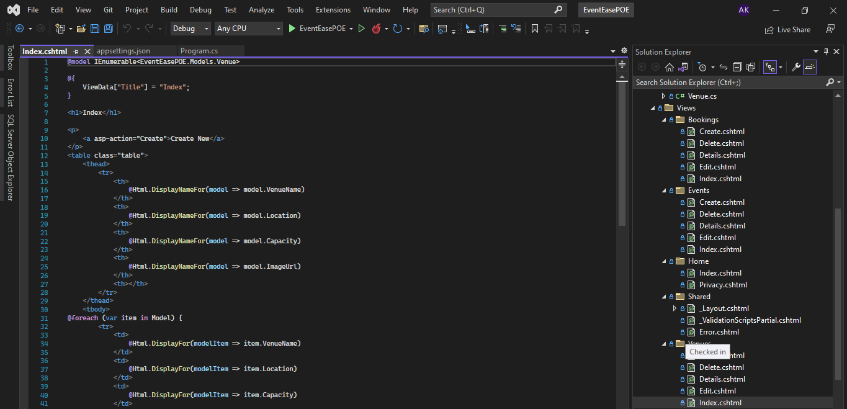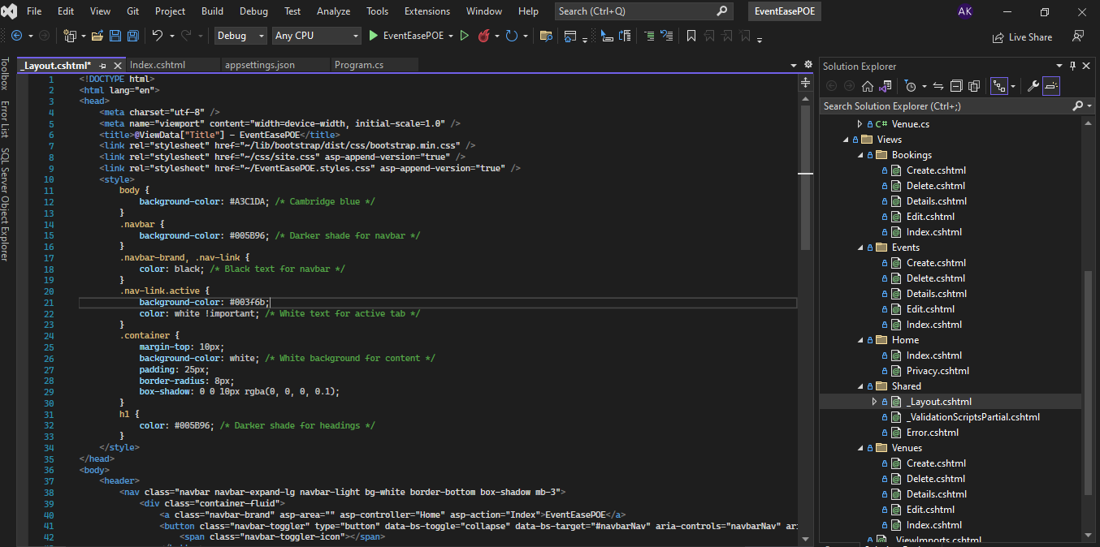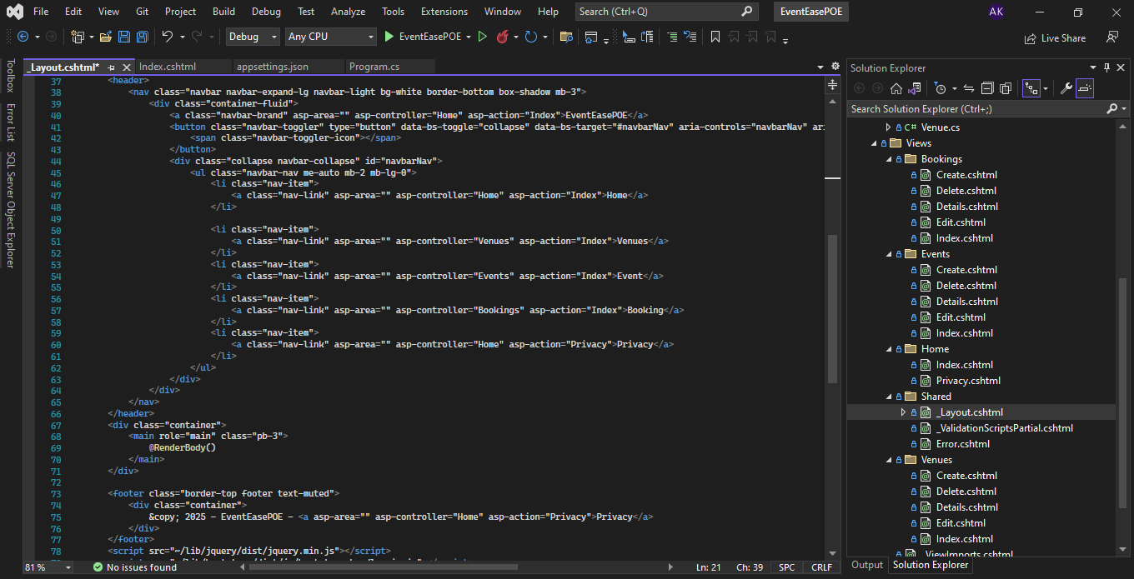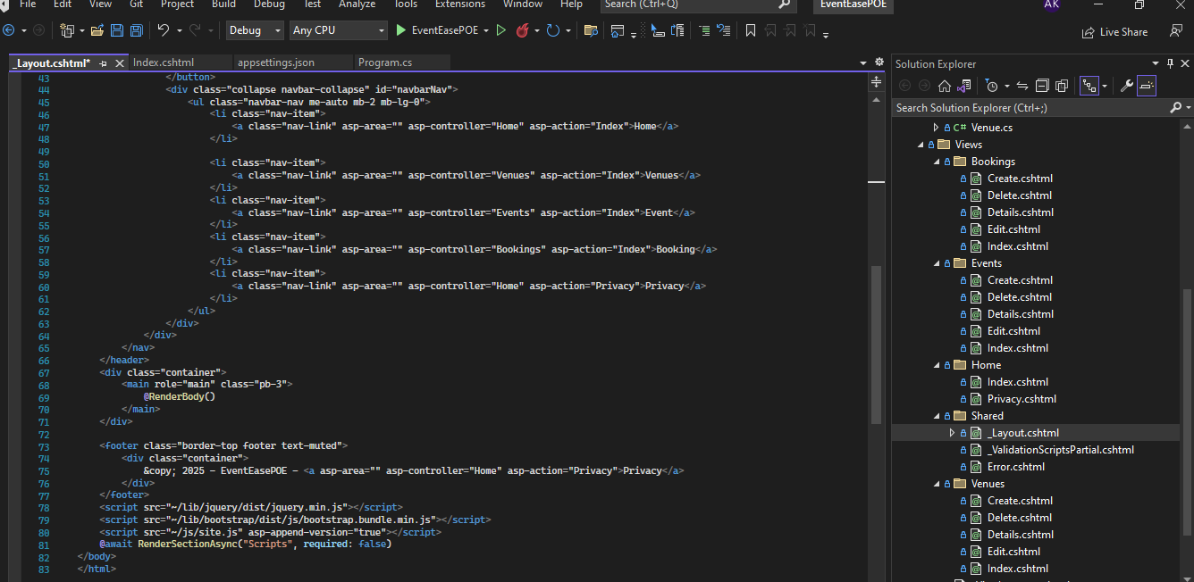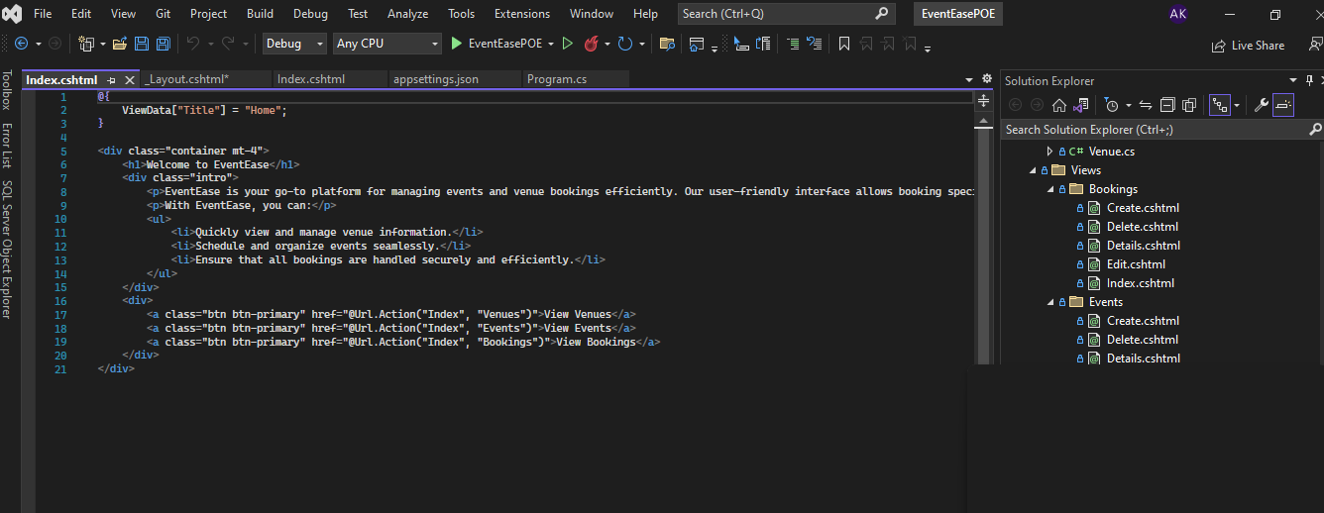

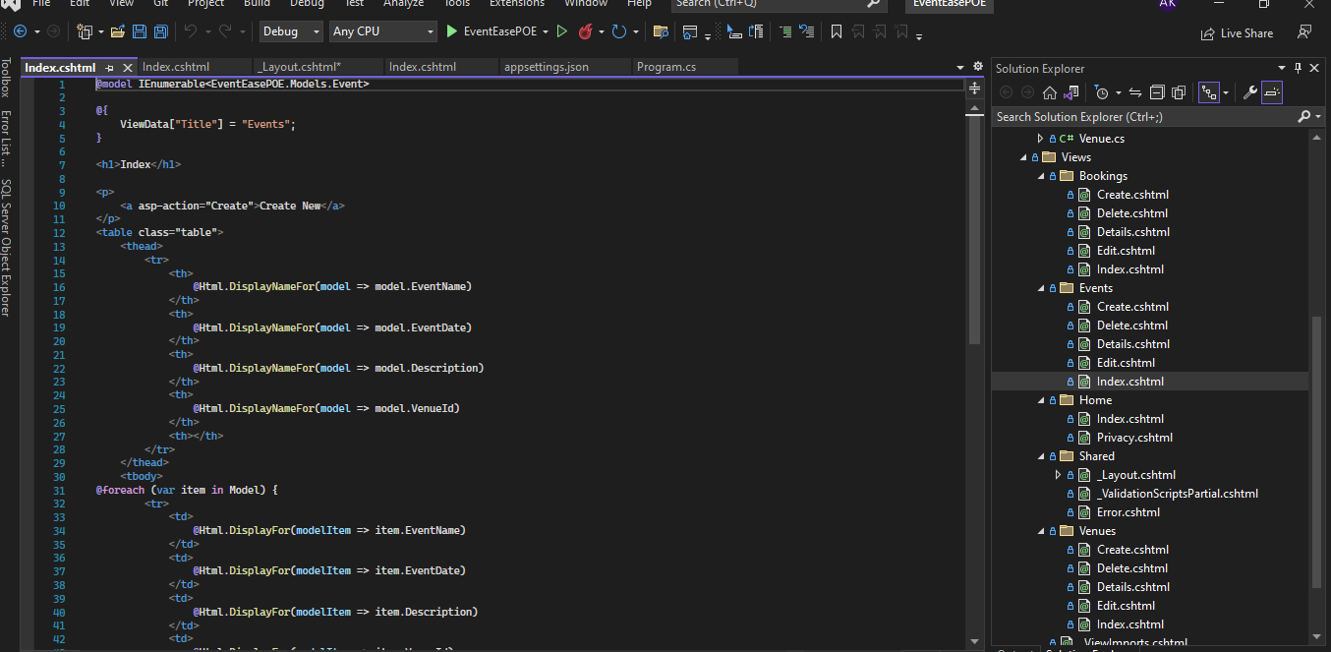

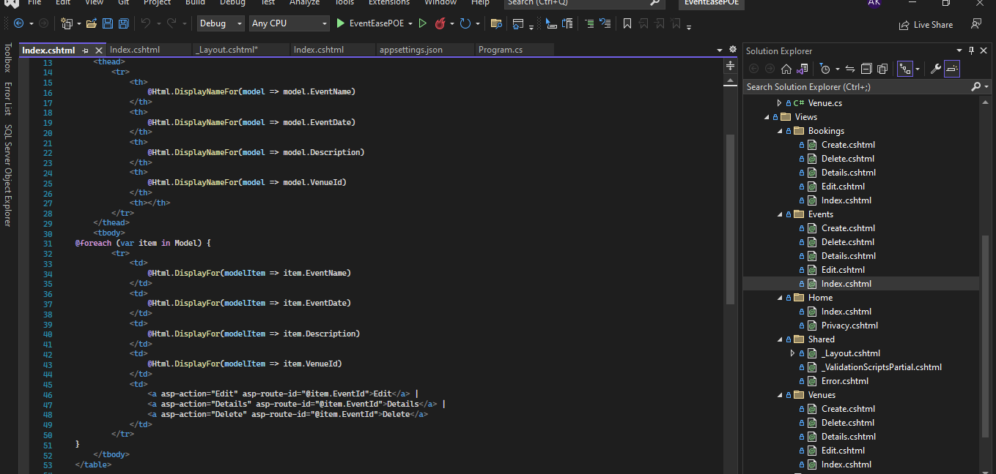

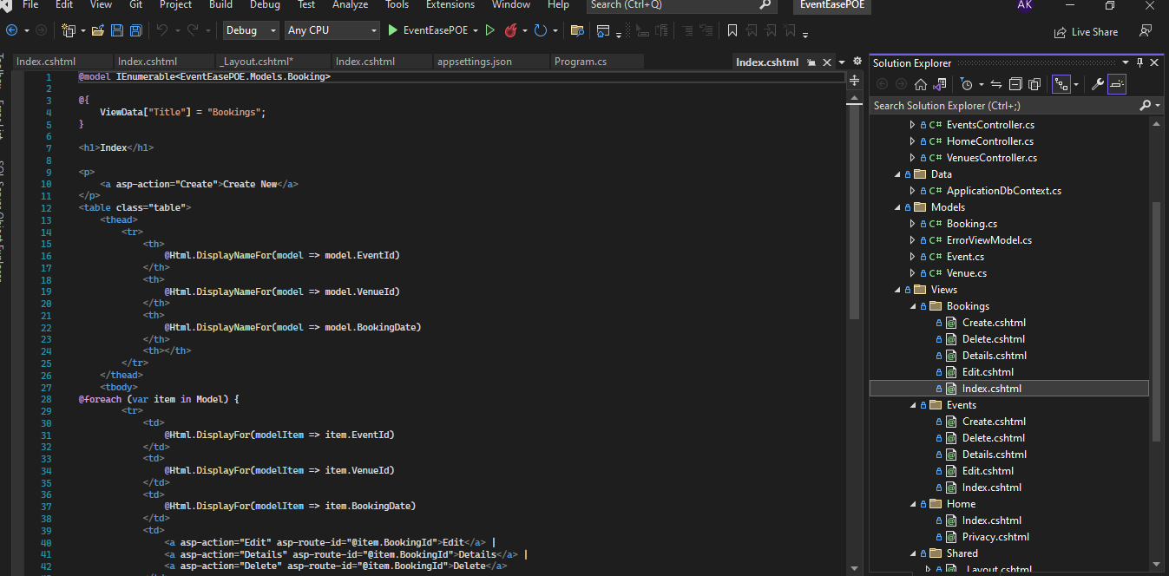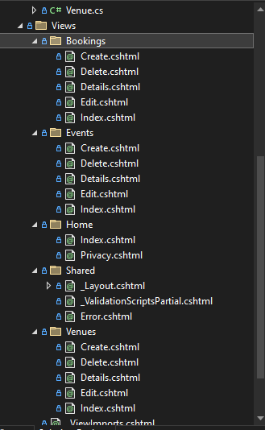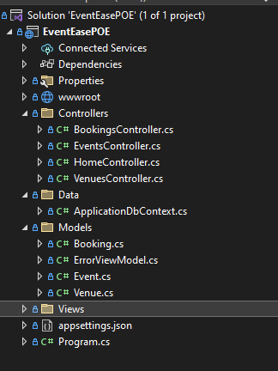

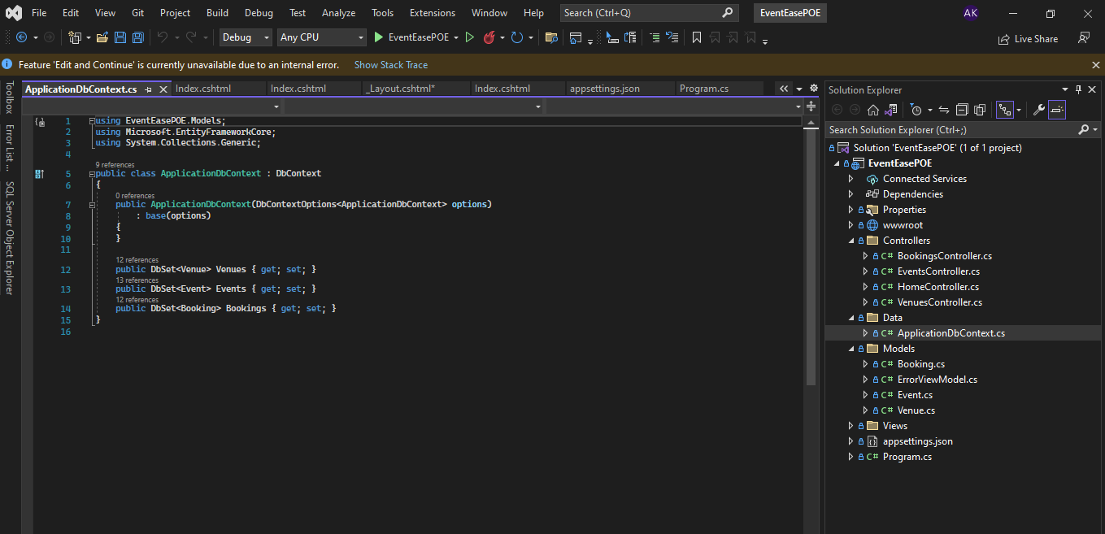

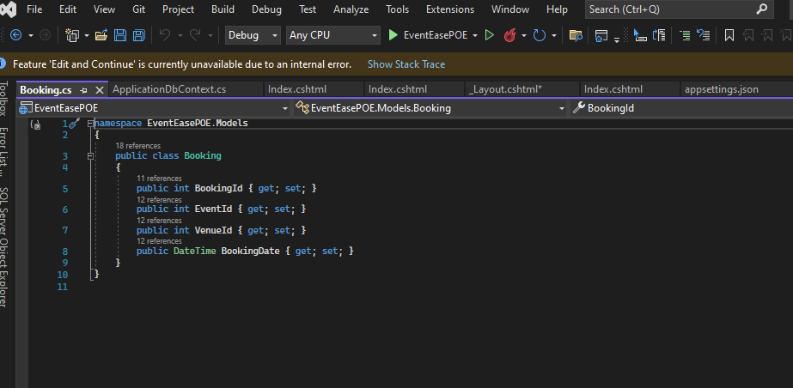

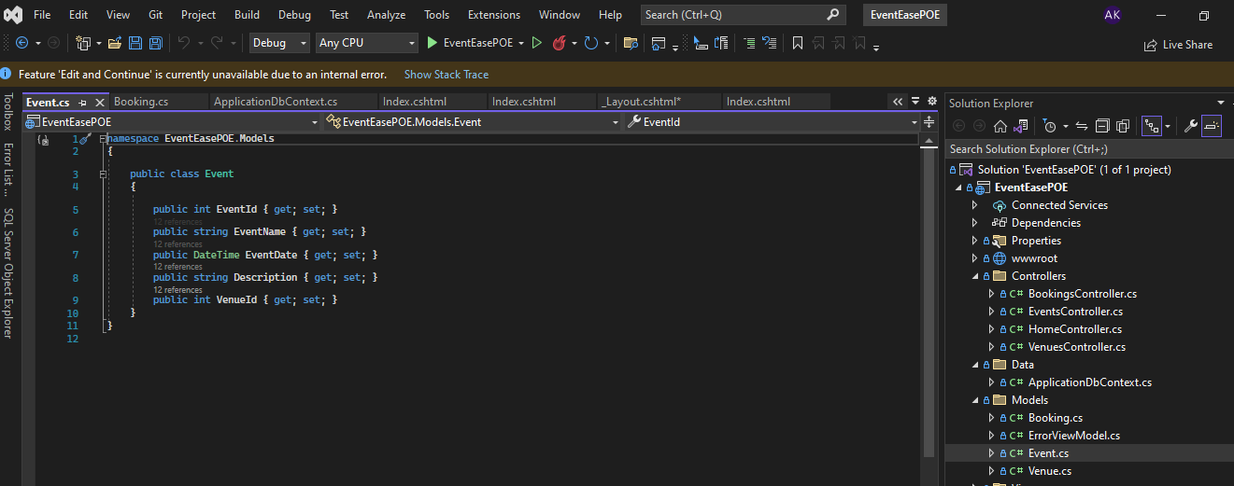

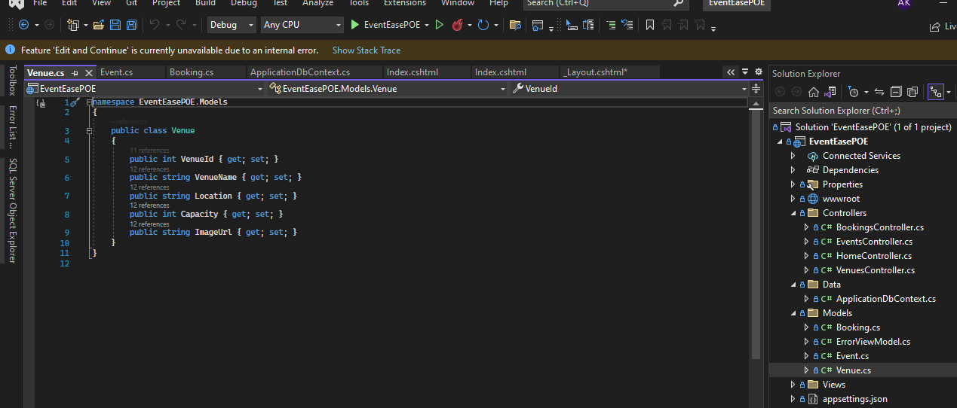

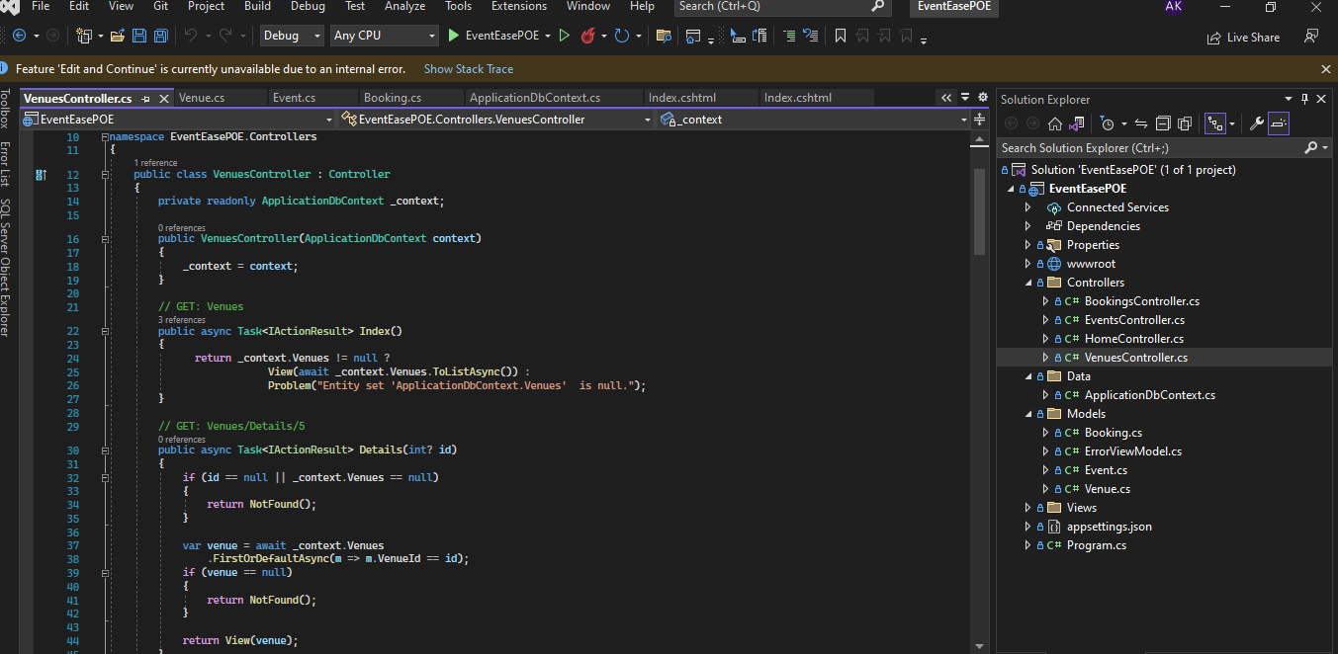

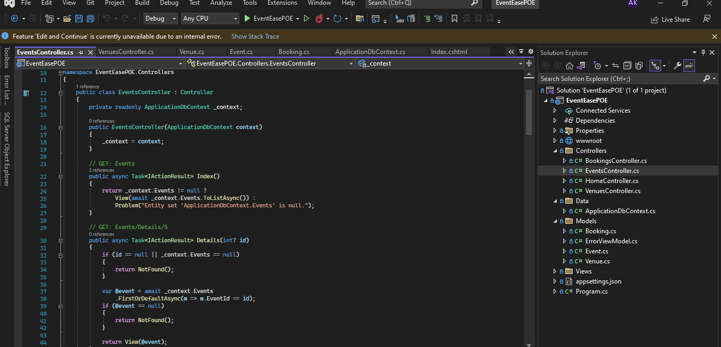

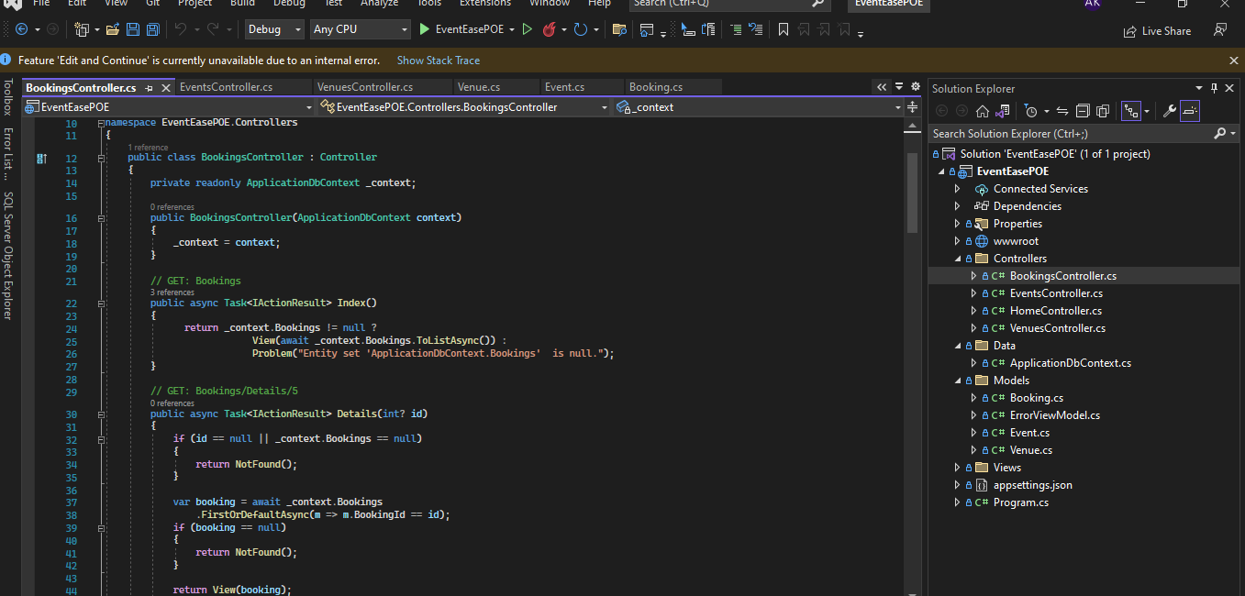

Screenshots of ssms

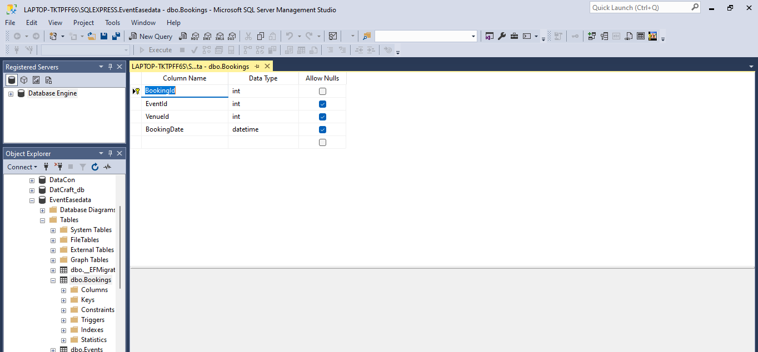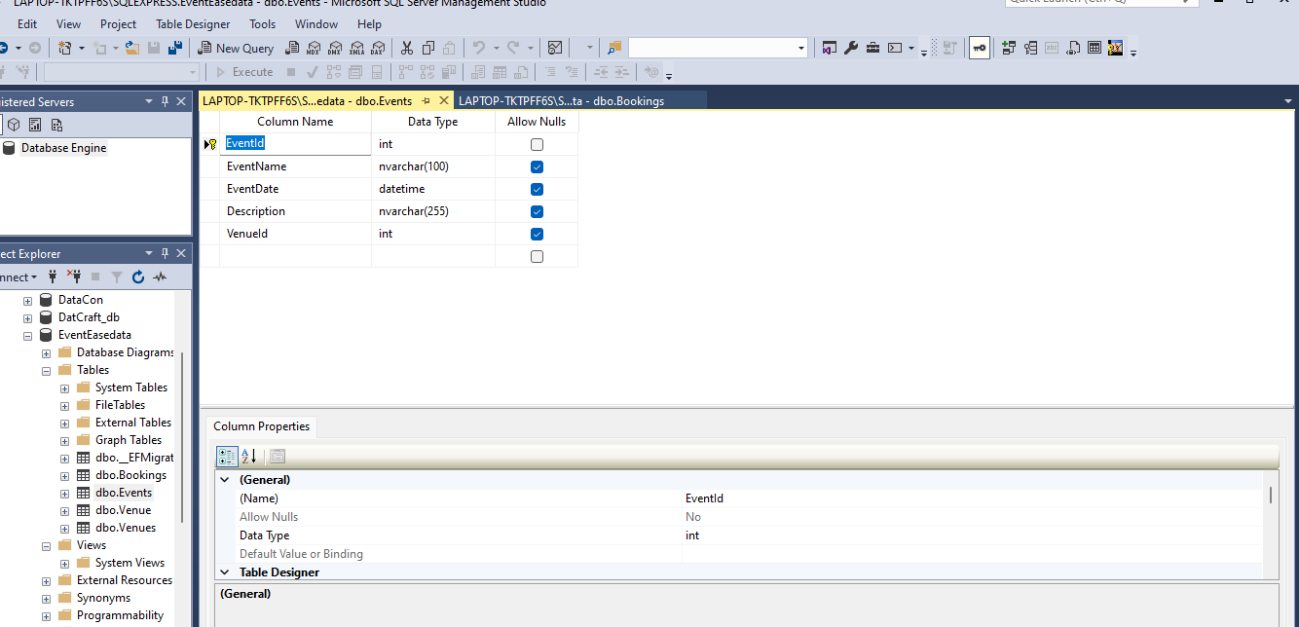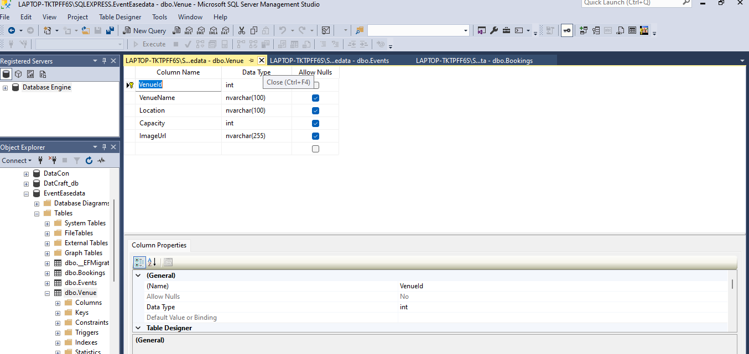

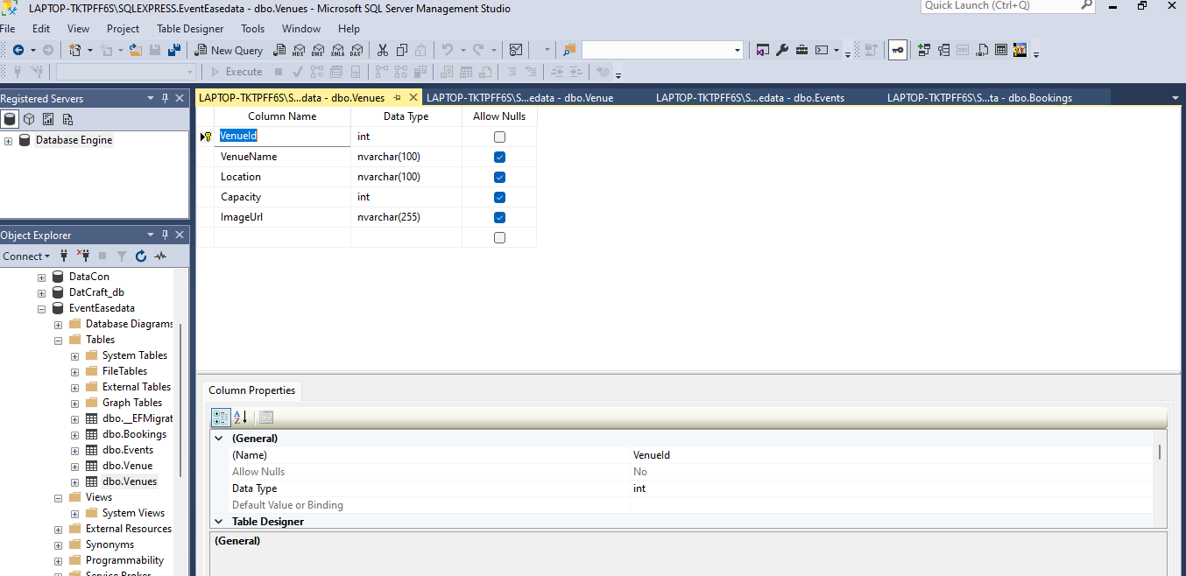

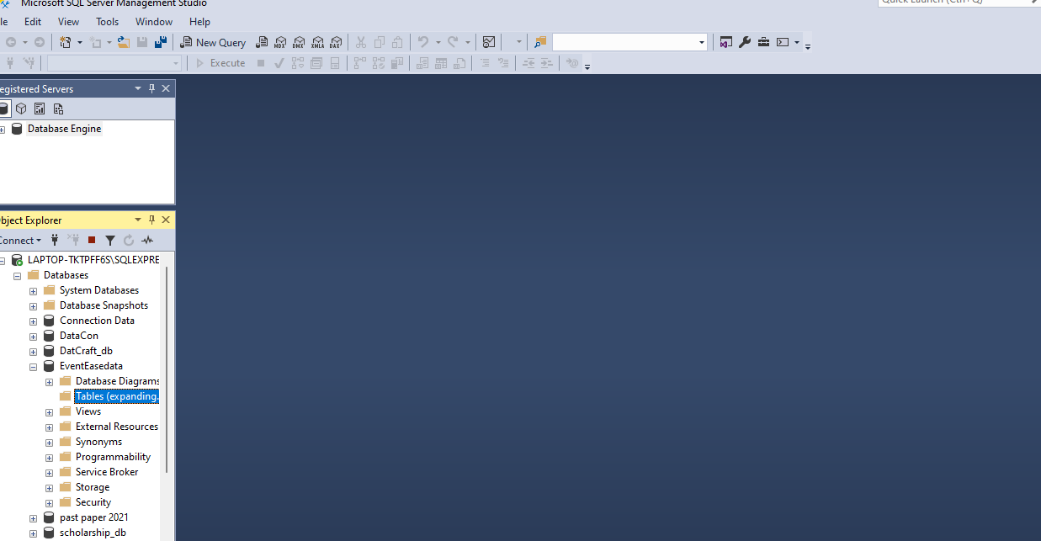

Screenshots of deployment

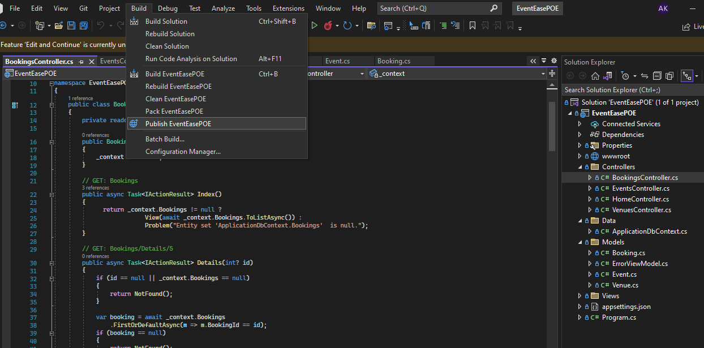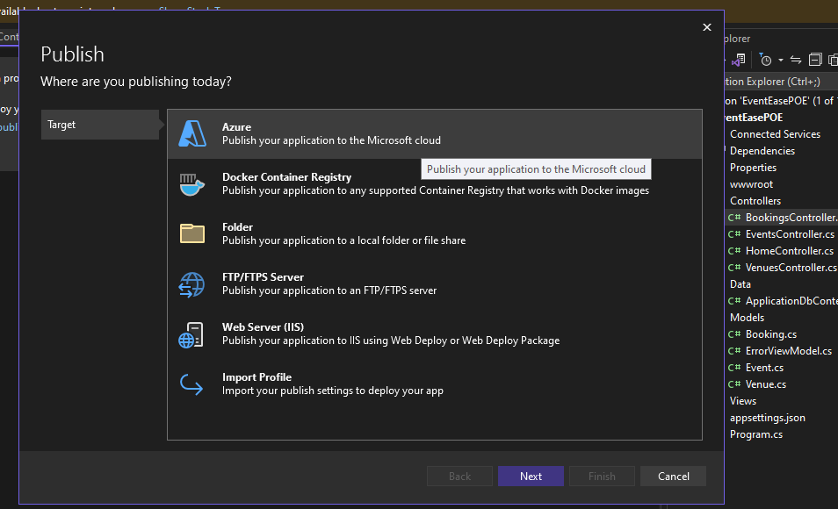

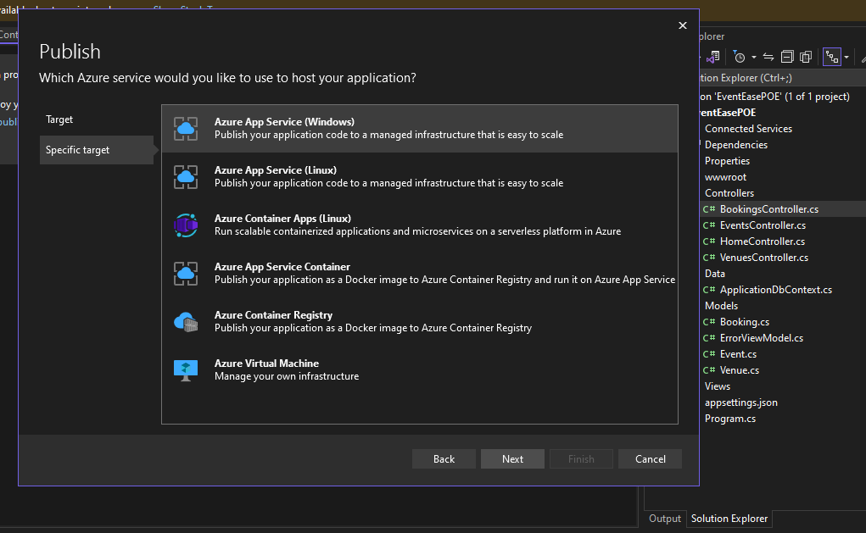

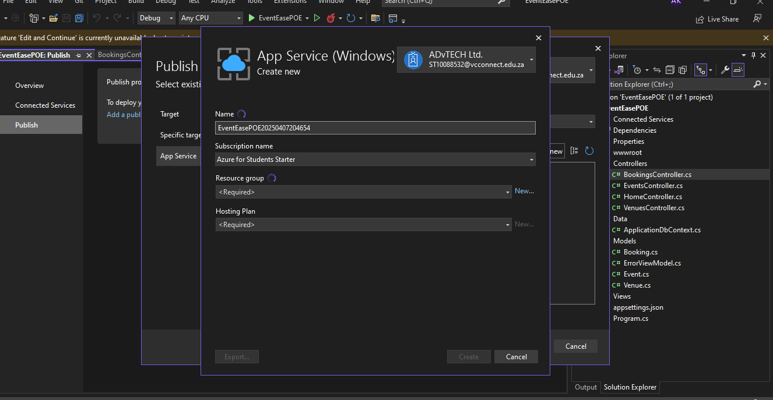

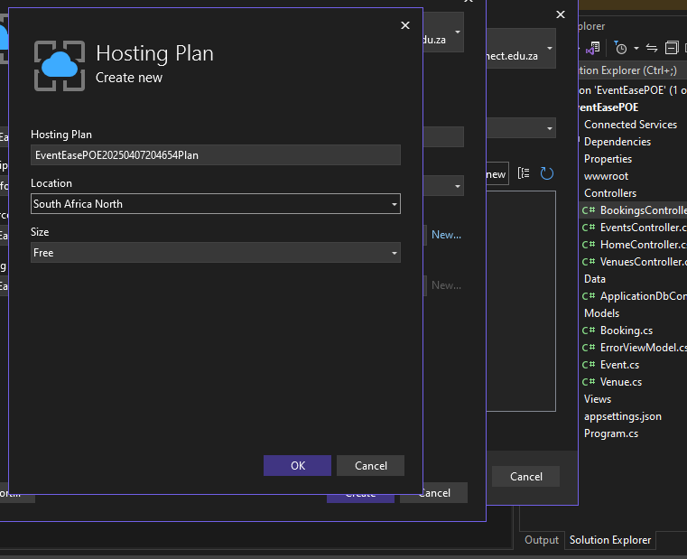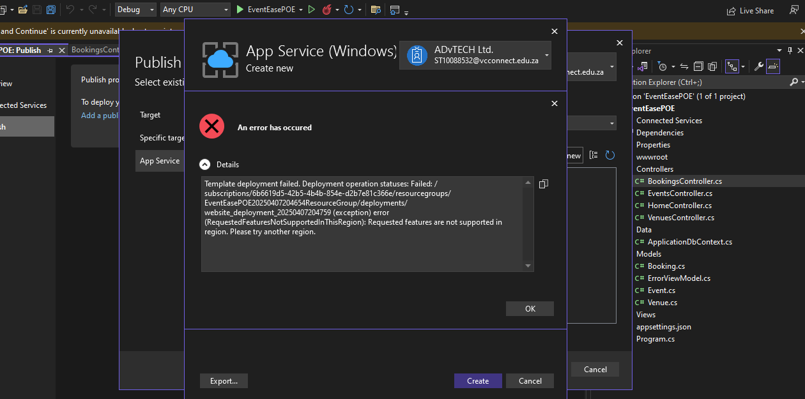

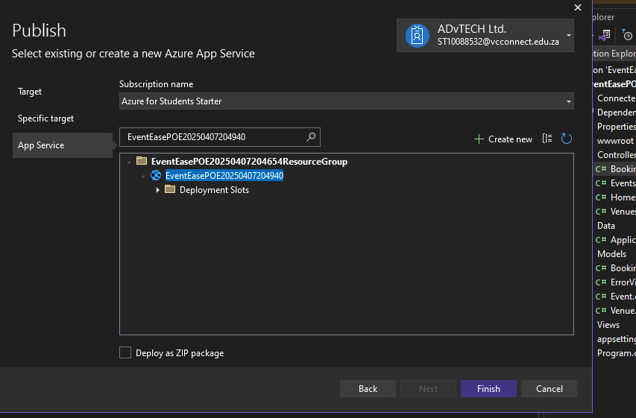

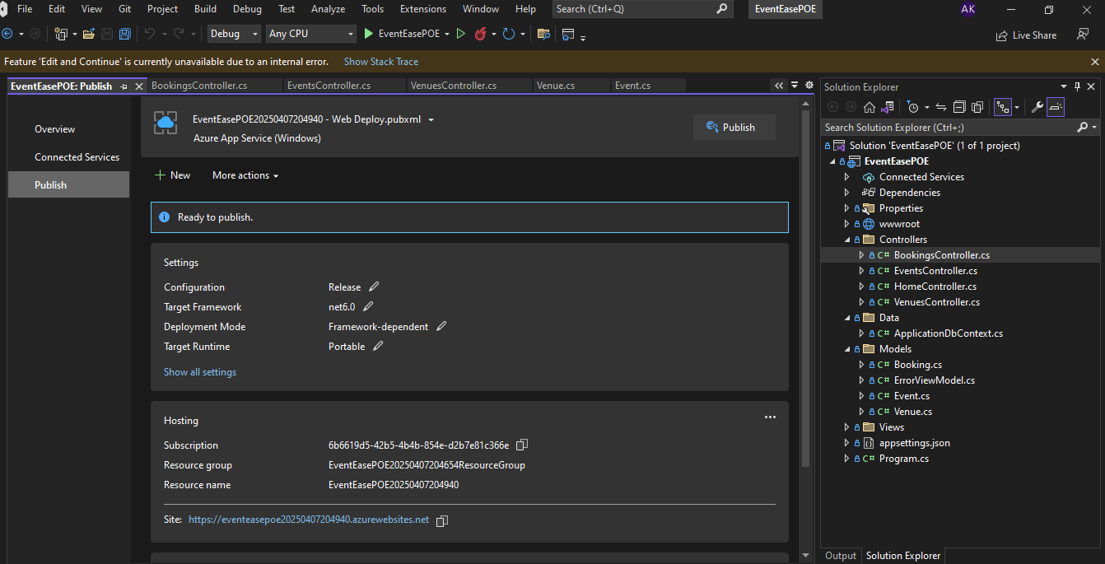

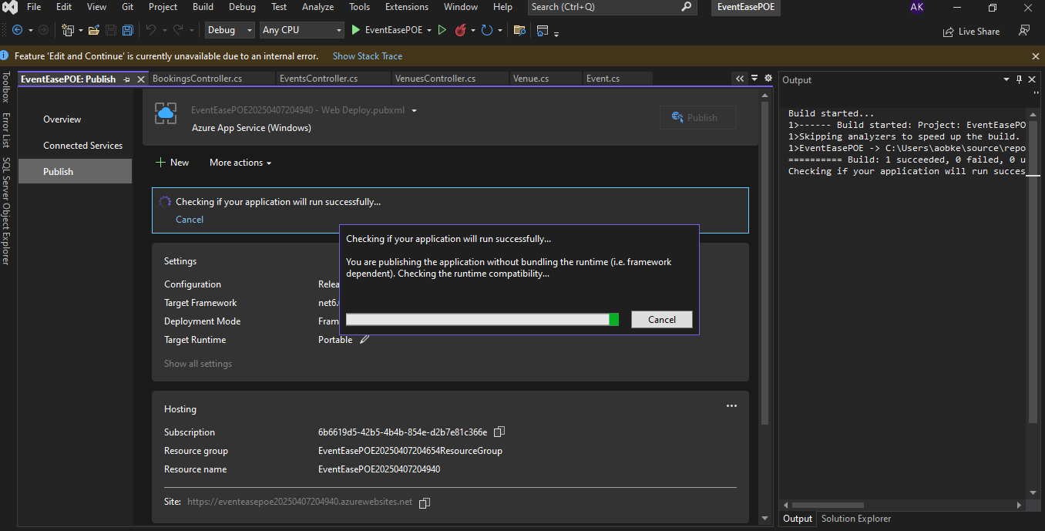

GIThub repository link

https://github.com/ST10088532/VCSANDTON-CLDV6211-ST10088532.git

Web app url

<https://eventeasepoe20250407204940.azurewebsites.net>

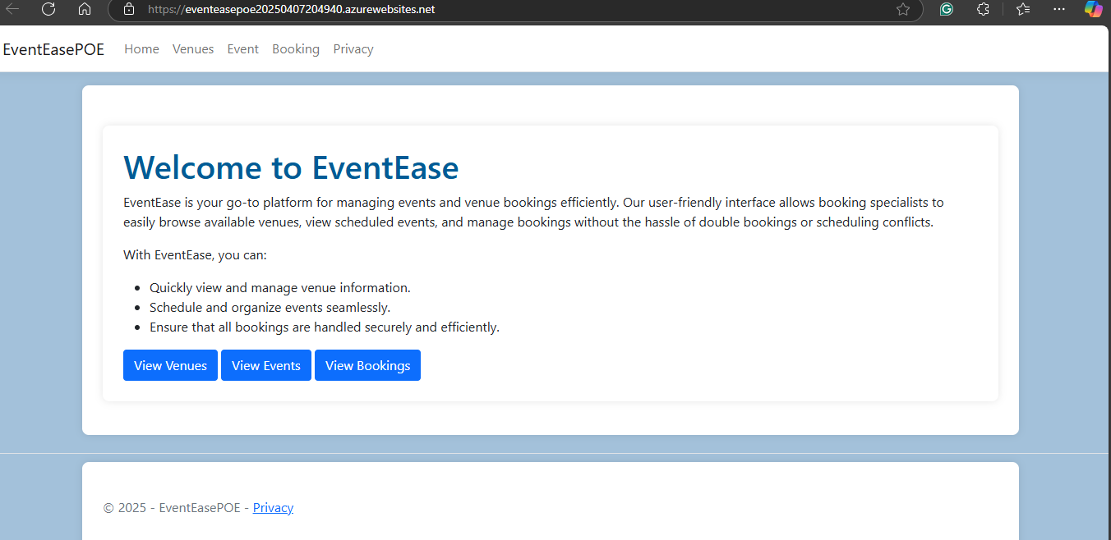

Part D

1. On-premise software is installed on a company's network/infrastructure. Cloud software relies on a provider’s servers and is accessed using the web. While cloud computing offers flexibility and cost-efficiency, on-premise options offer dependability, security, and control. Mostly a blend of on-premise, cloud and SaaS applications is necessary for continued business growth.

Example, If EventEase decided to deploy on-premises they would need to hire cybersecurity employees/workers to setup firewalls, check the network and system for any threats and make sure the physical server secure.

1. IaaS is an on-demand access to cloud-hosted physical and virtual servers, storage and networking—the backend IT infrastructure for running applications and workloads in the cloud. PaaS is on-demand access to a complete, ready-to-use, cloud-hosted platform for developing, running, maintaining and managing applications.  
   SaaS, or software as a service, is on-demand access to ready-to-use cloud-hosted application software. (Mrzyglod, 2022) (Ron Karjian, 2024) (S., n.d.)

Example EventEase use Iaas so they need to configure virtual machines, install web servers and manage Operating system patches/updates. With Saas they would have to adapt their business processes to fit available software. With Paas comes the perfect balance by using Azure App Service and Azure SQL Database, EventEase can deploy their event booking app, while maintaining control over their application's functionality and user experience. (Mrzyglod, 2022) (Ron Karjian, 2024) (S., n.d.)

# Part 2

Azure database creation:

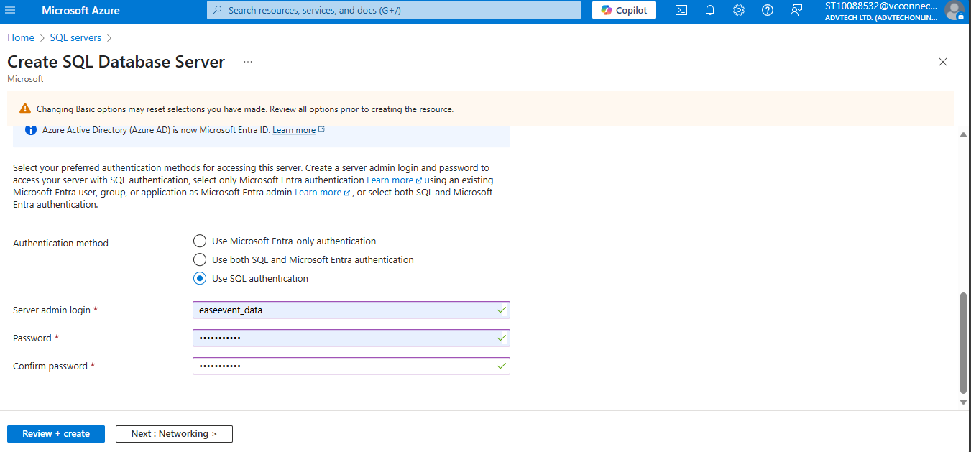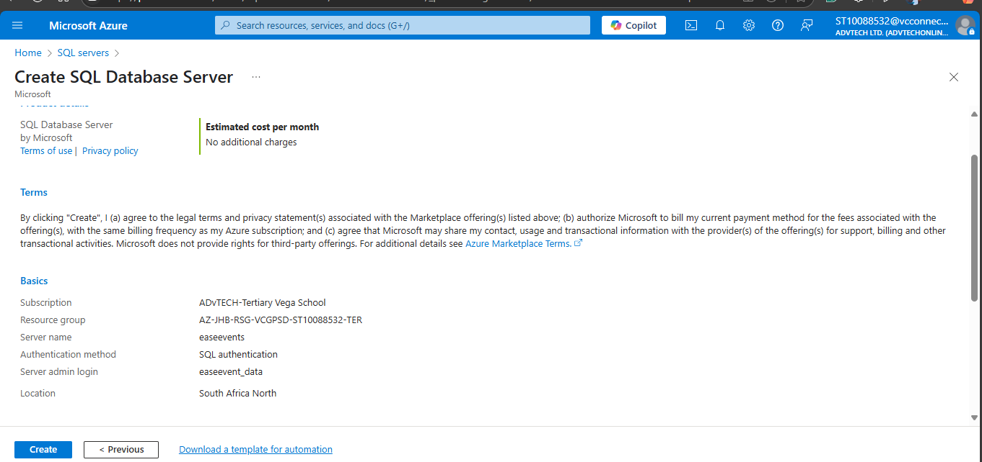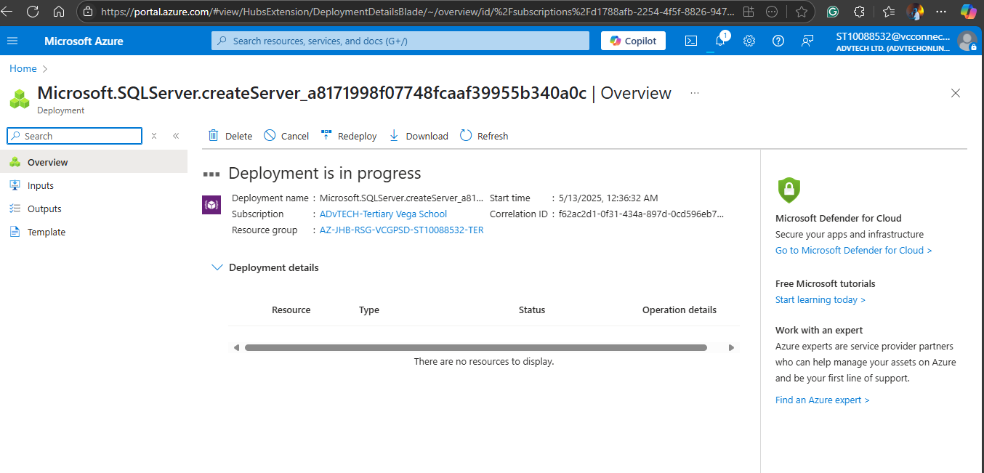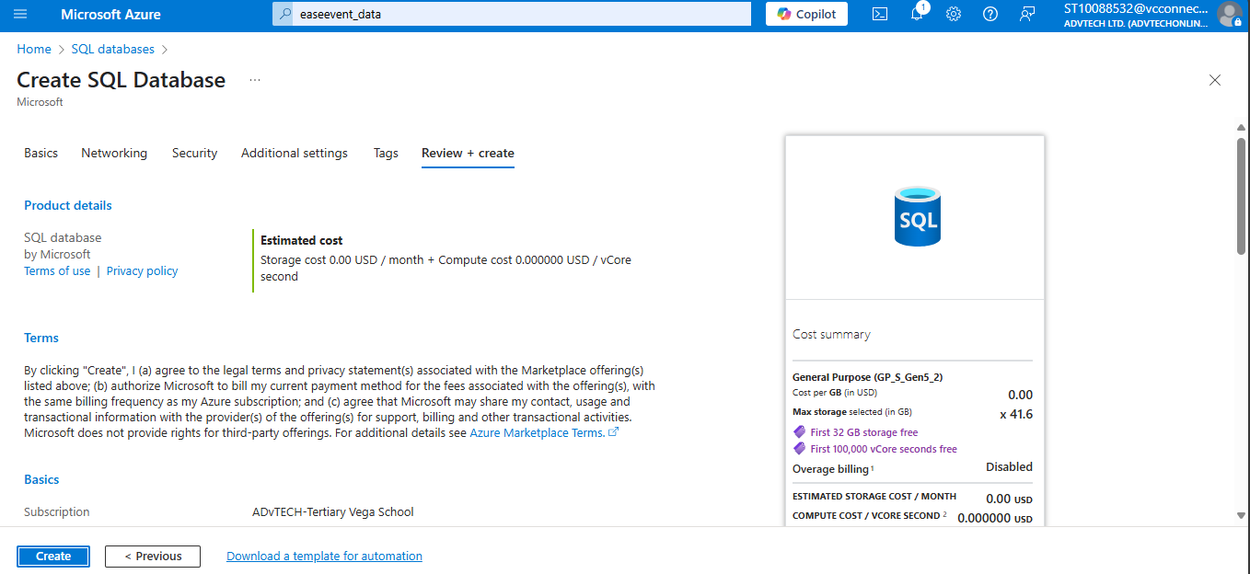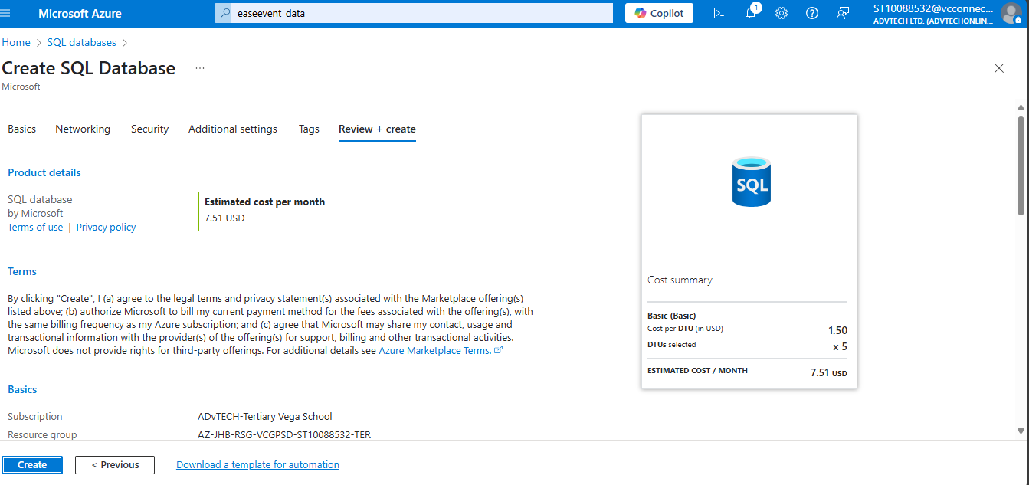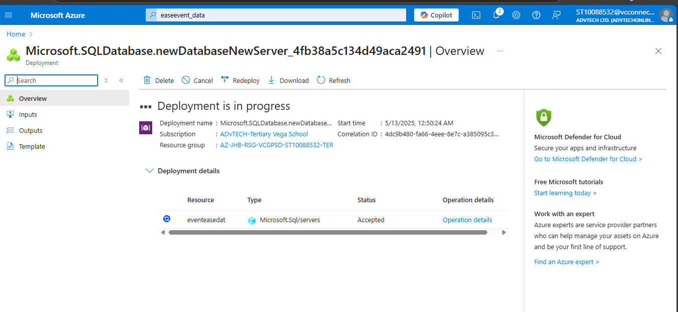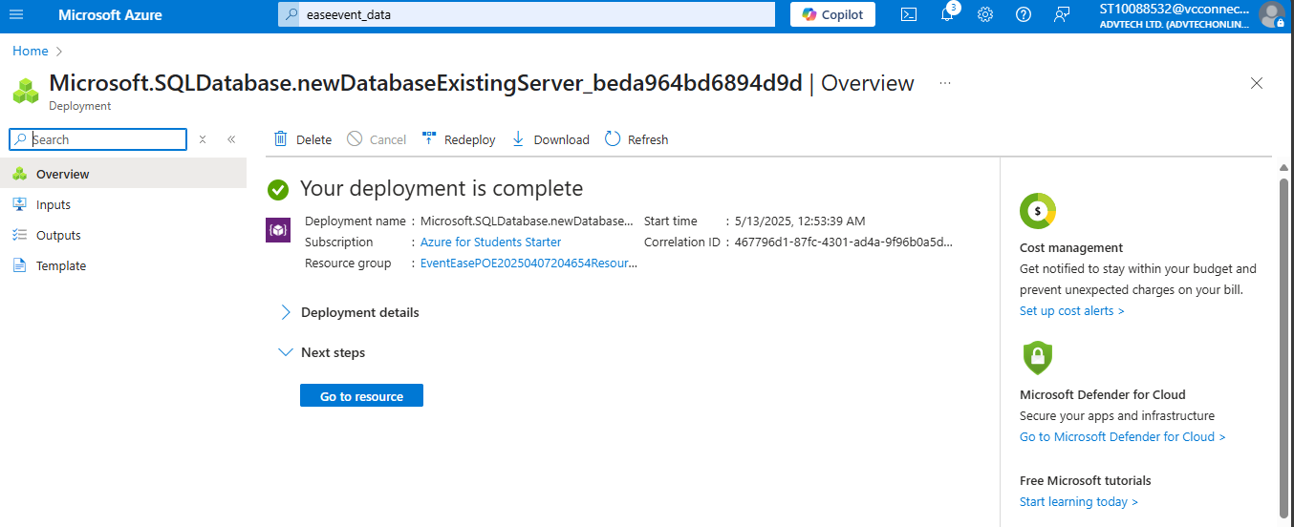

Code Corrections:

Updated json file with azure connection string.

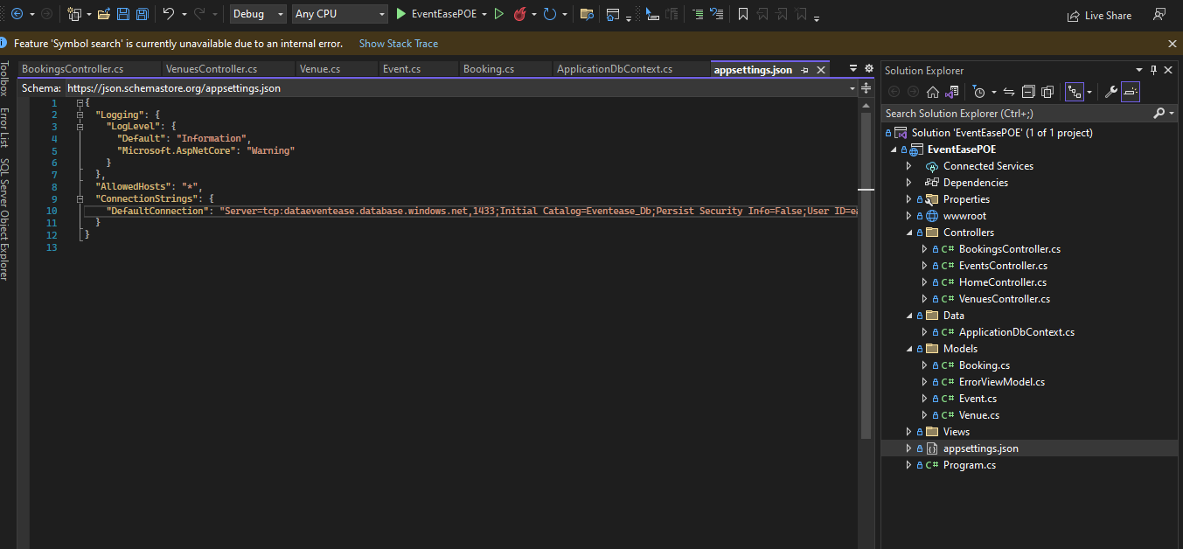

Updated connection to azure:

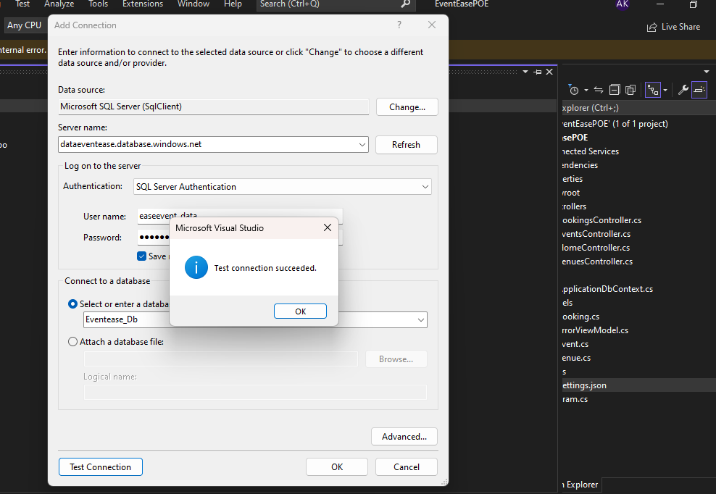

Adding Migrations and Updating Database:

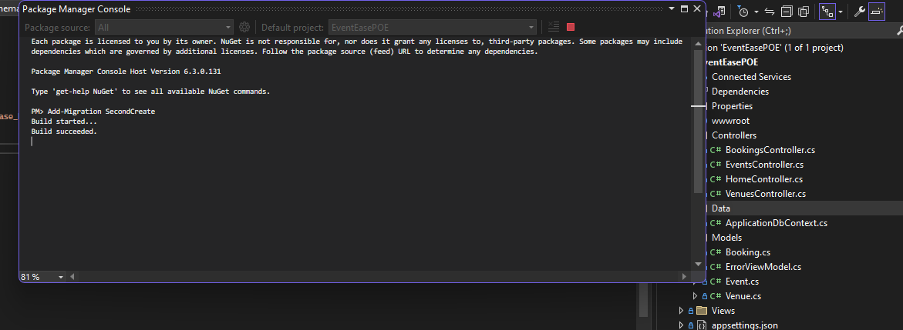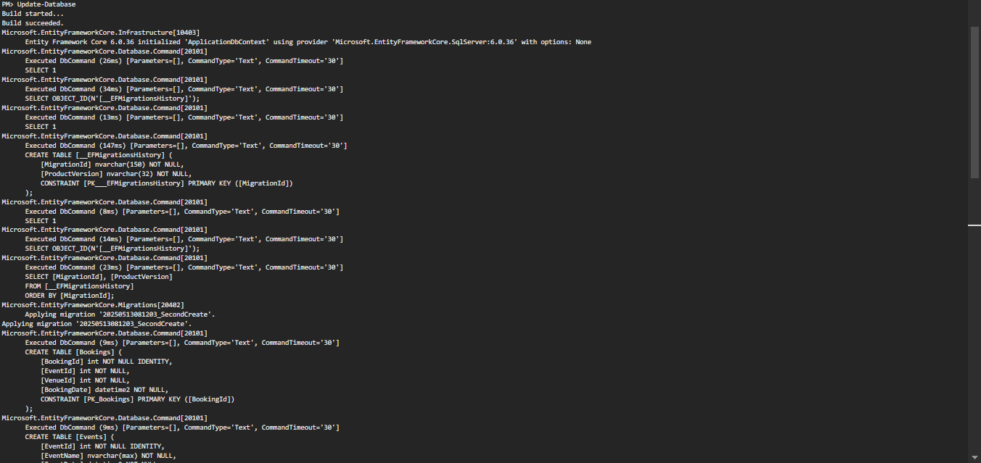

1. Creating Azure Storage Account

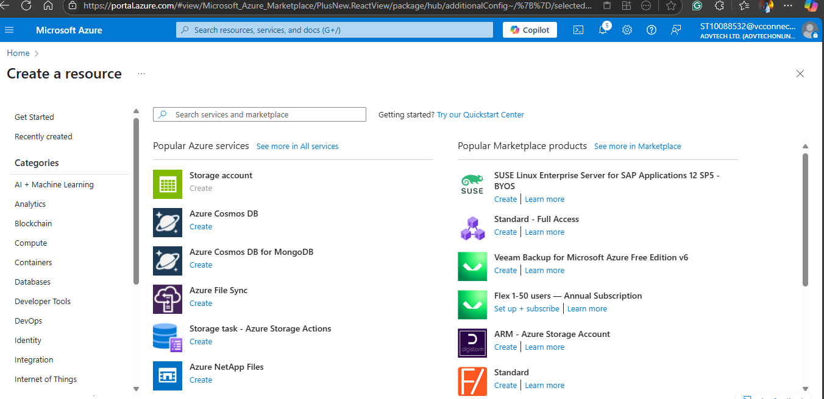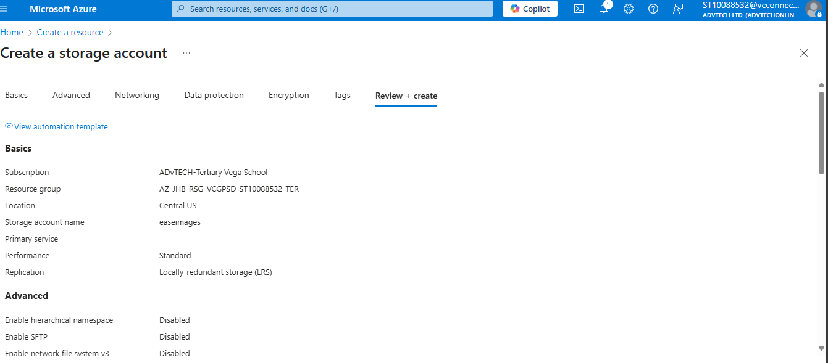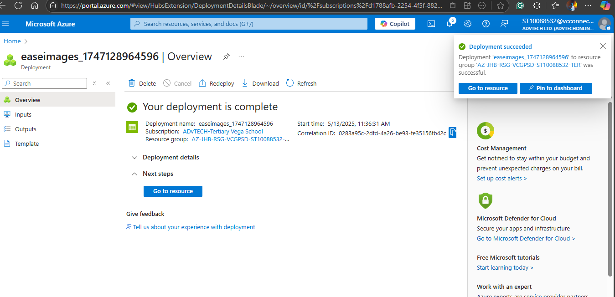

Integration of Azure Storage:

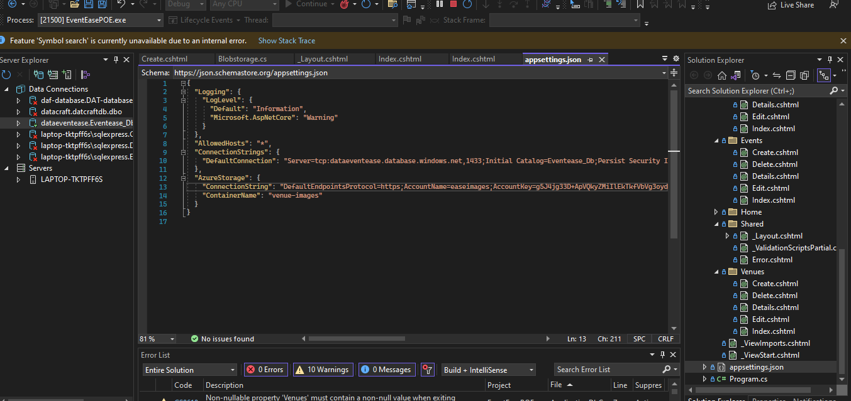

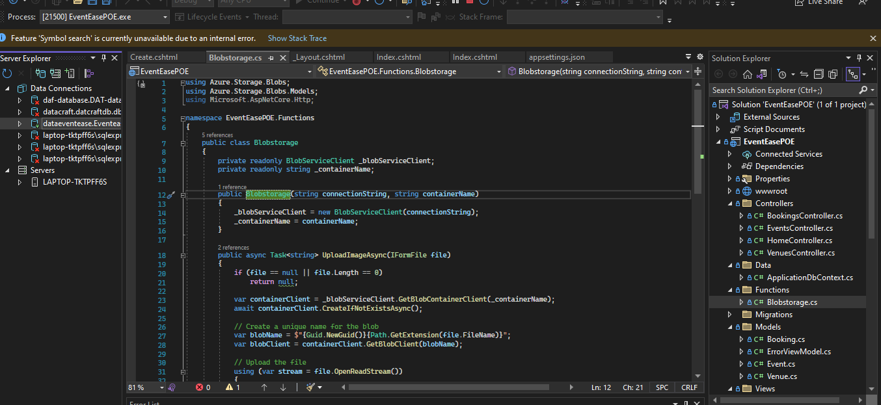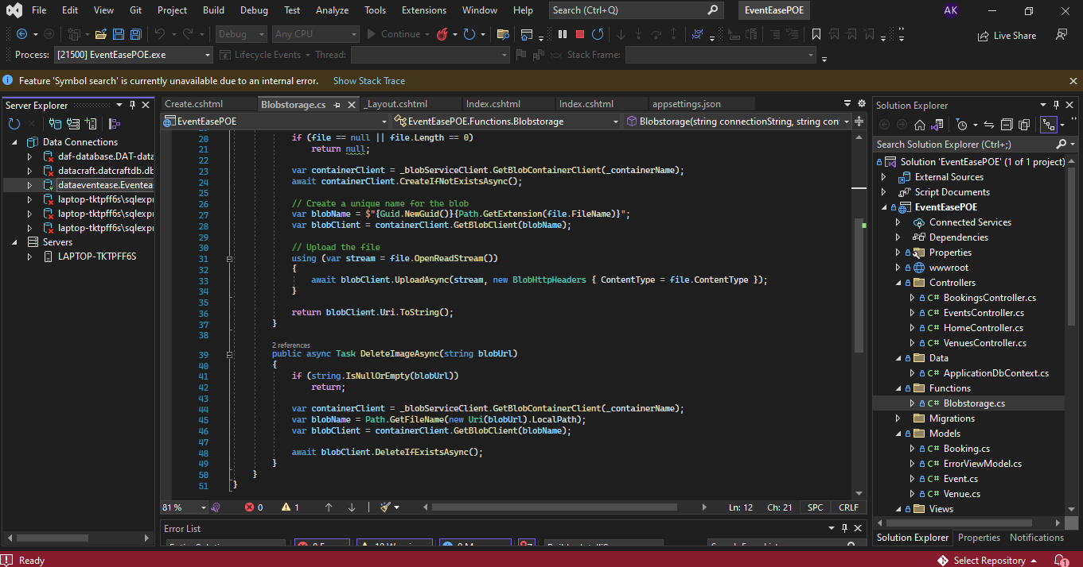

1. Implementing error handling and validations

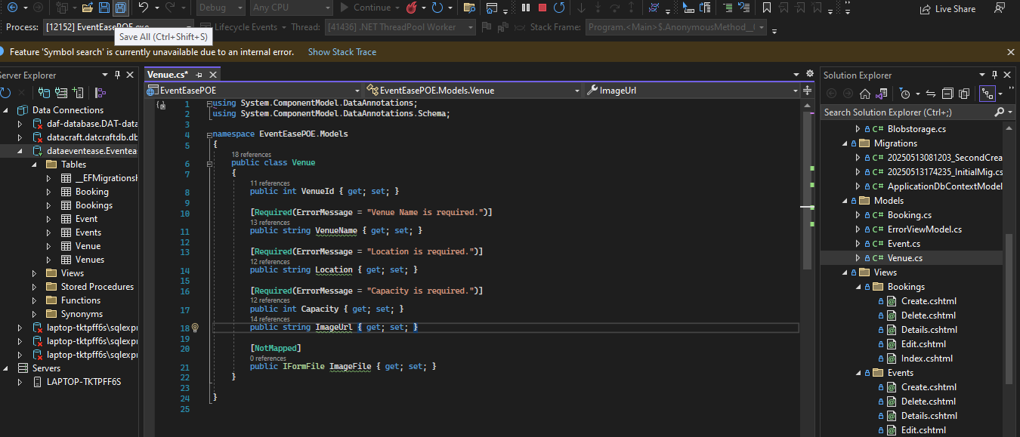

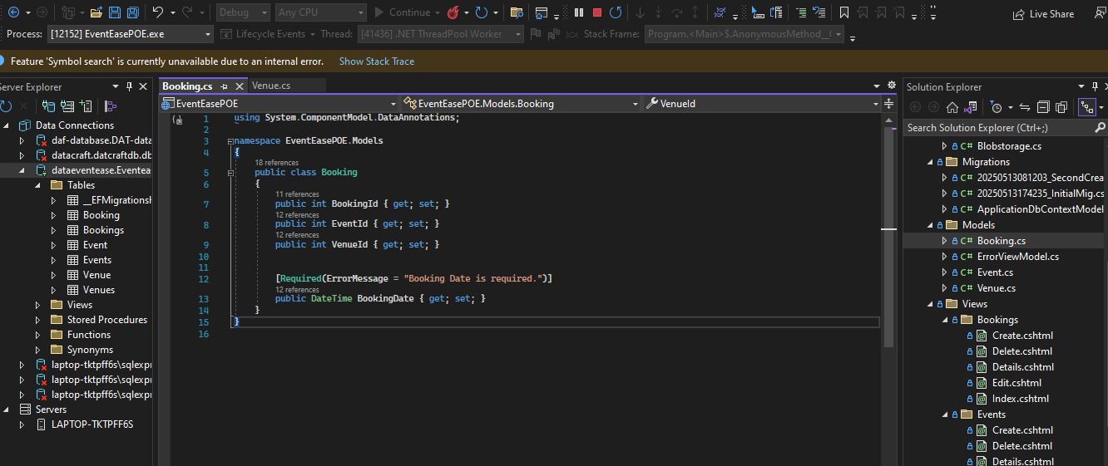

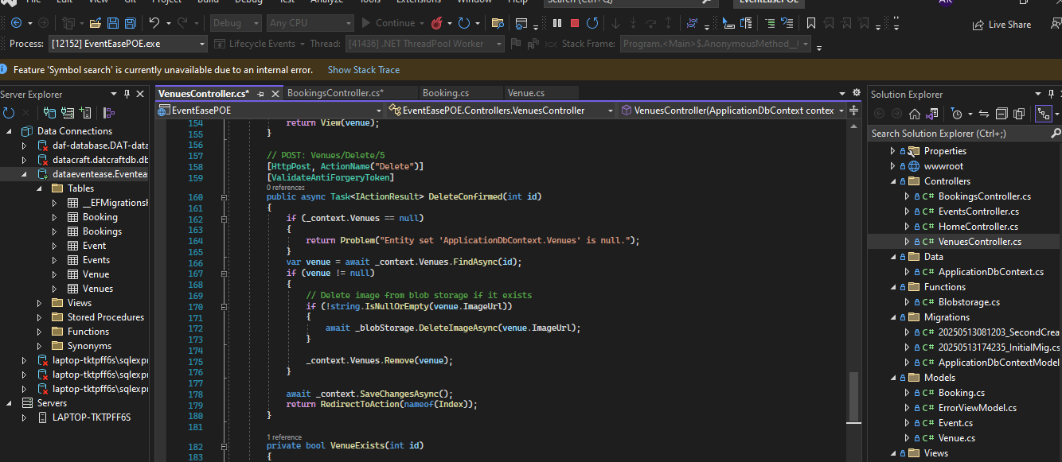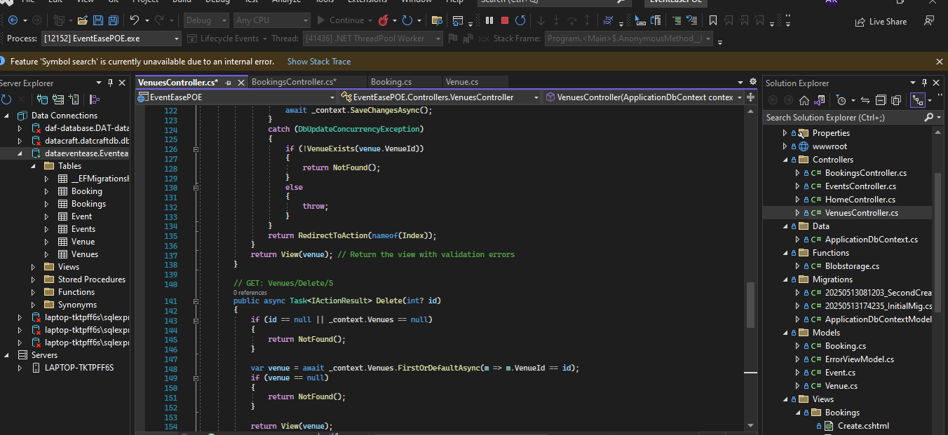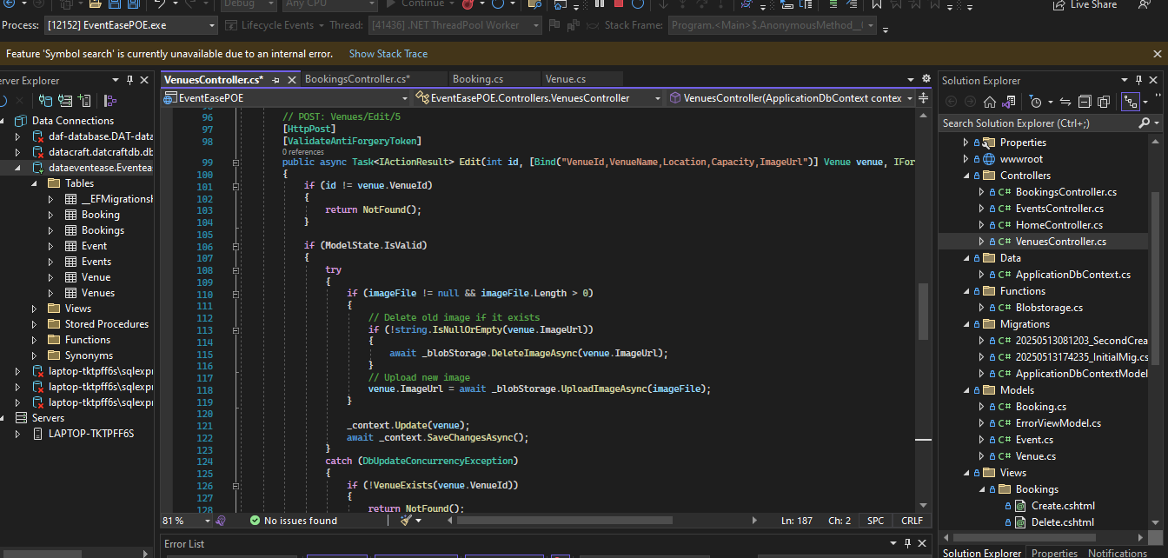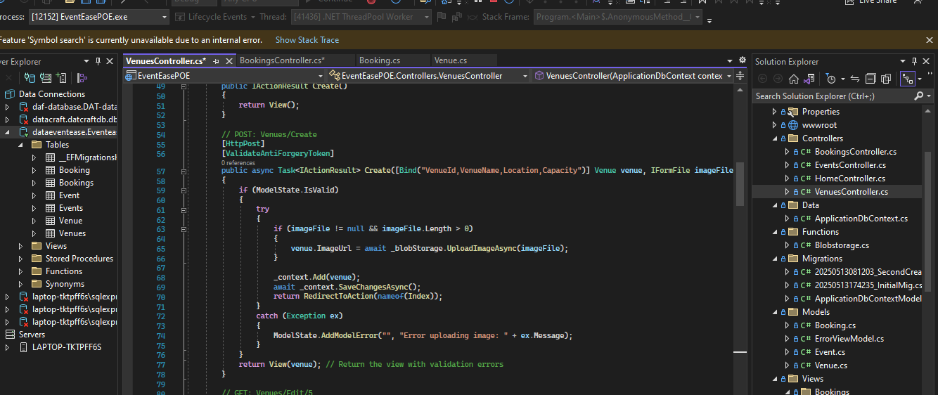

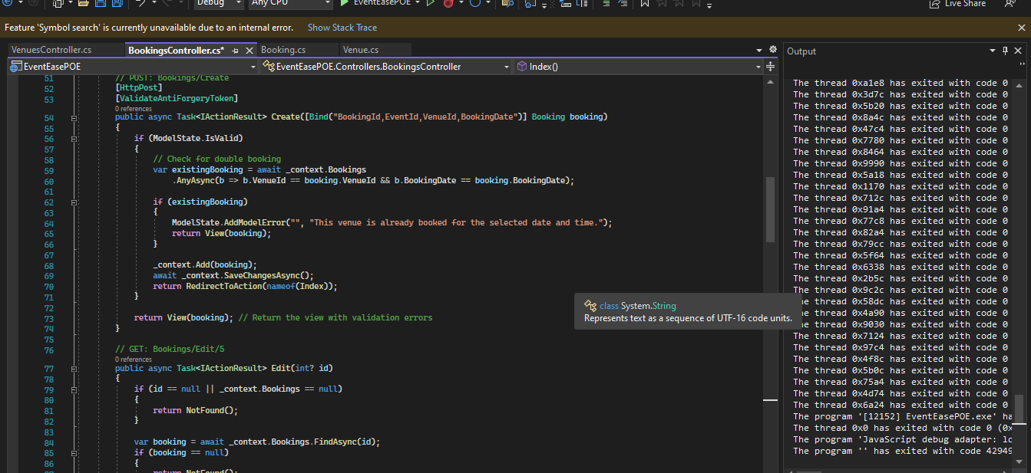

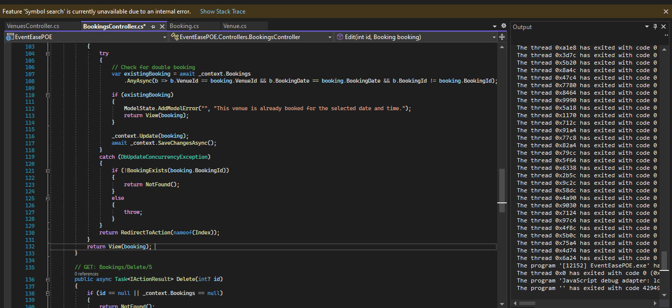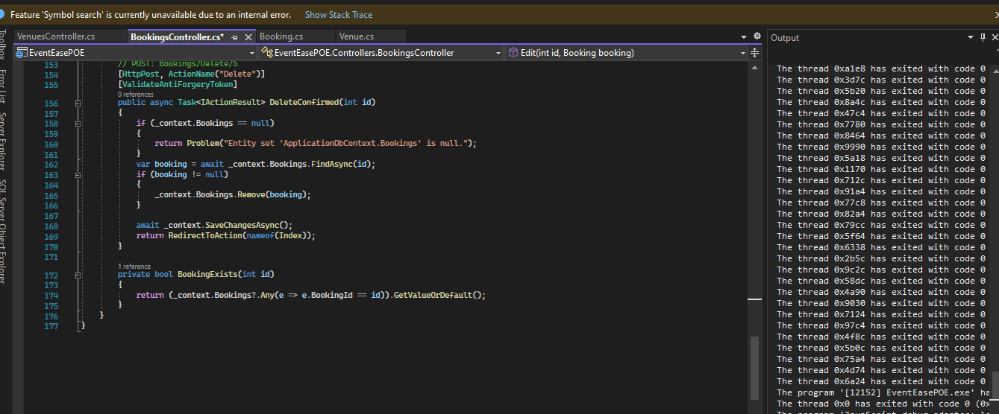

1. Enhanced Display and Search:

Booking view class:

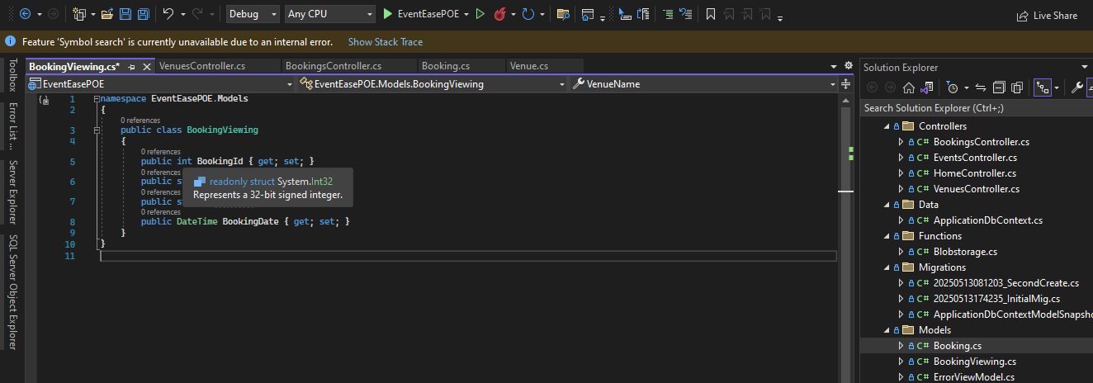

Improved index class/cshtml:

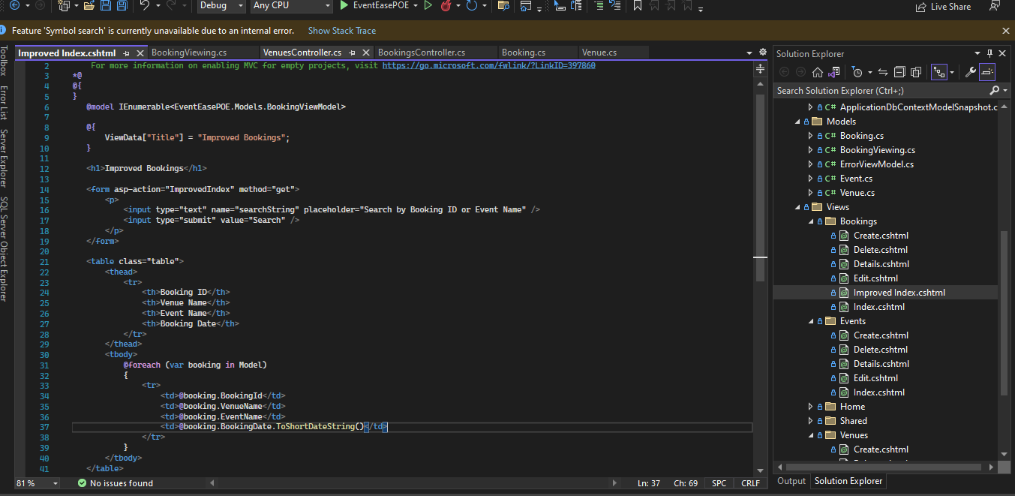

Improved index added to bookings controller:

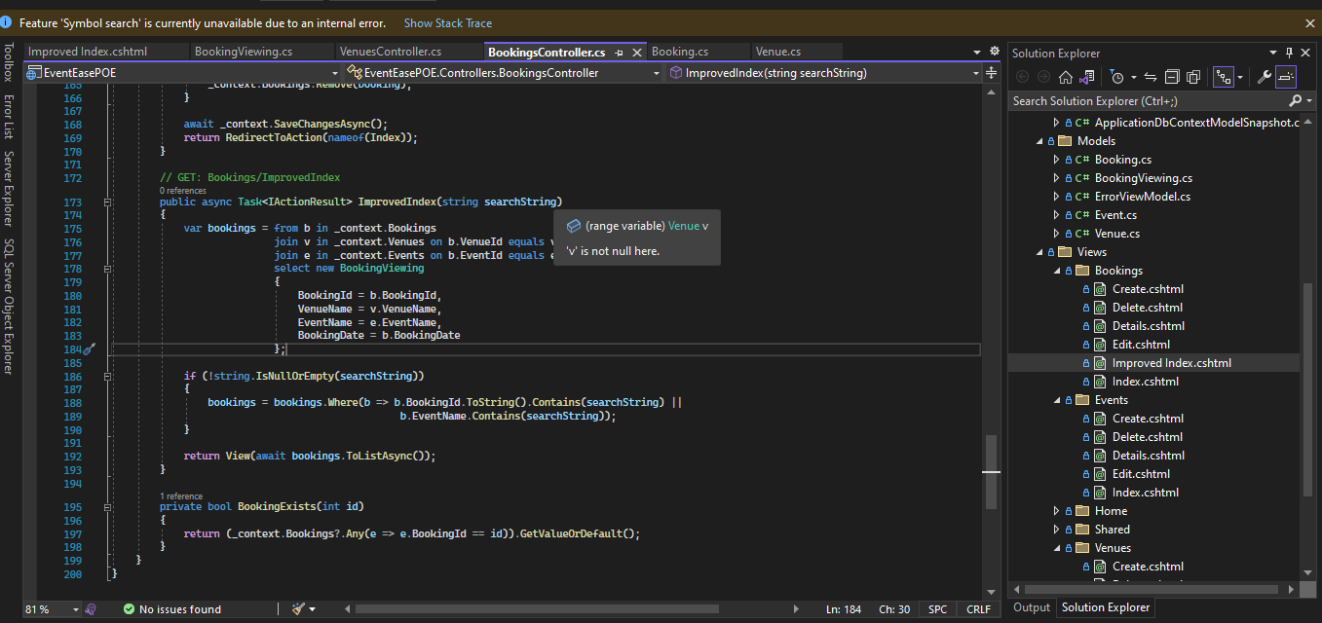

(BillWagner, 2024)

Database Update:

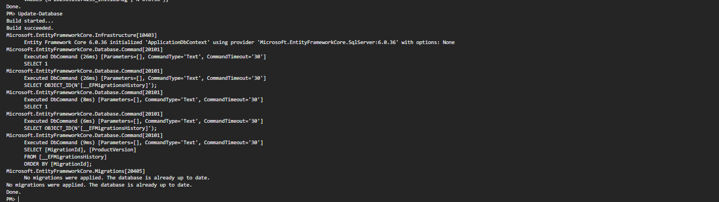

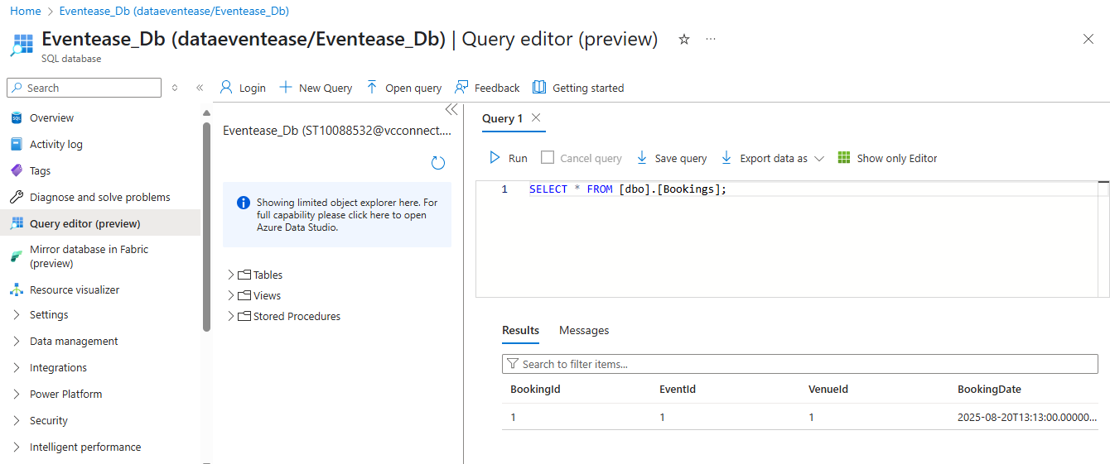

1. Azure deployment Updates:

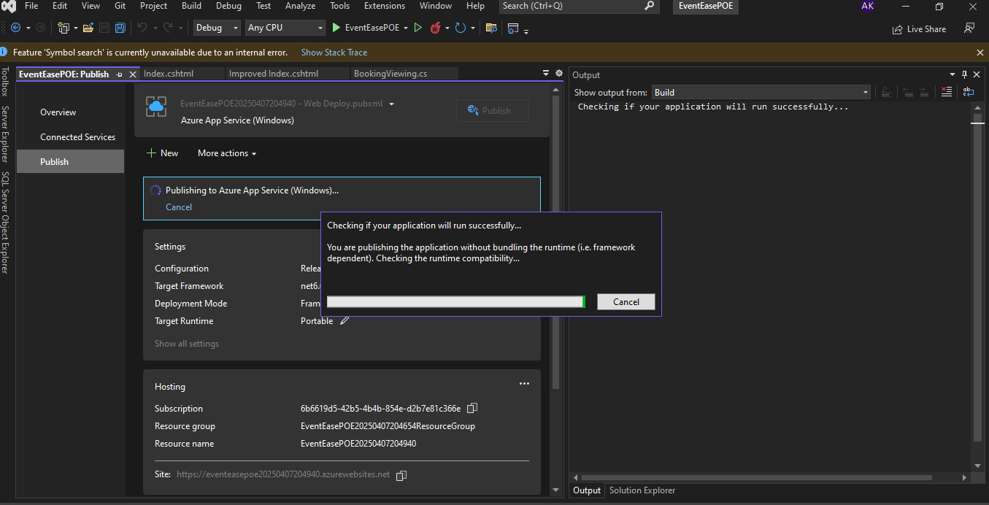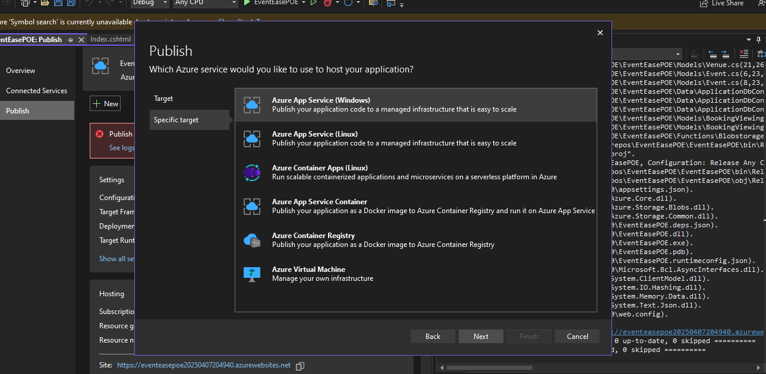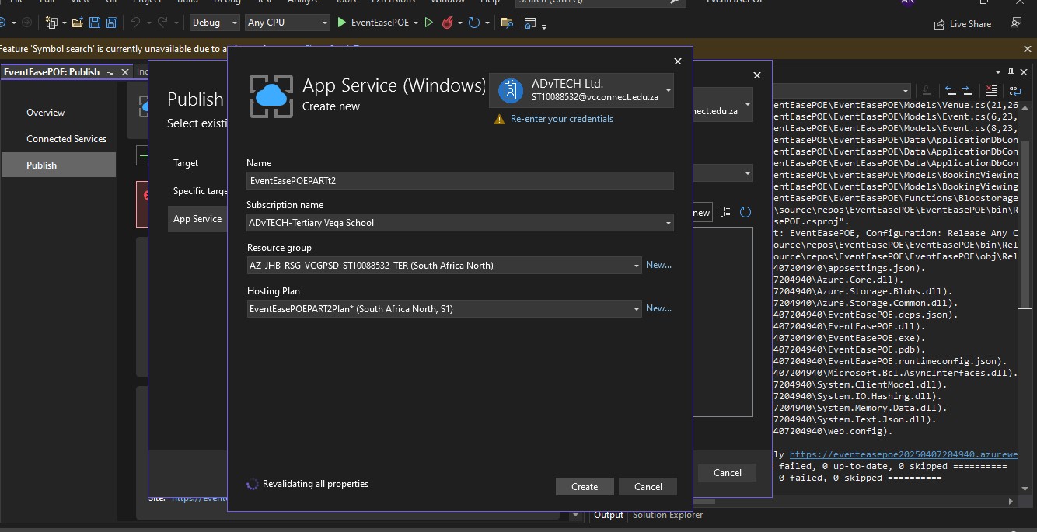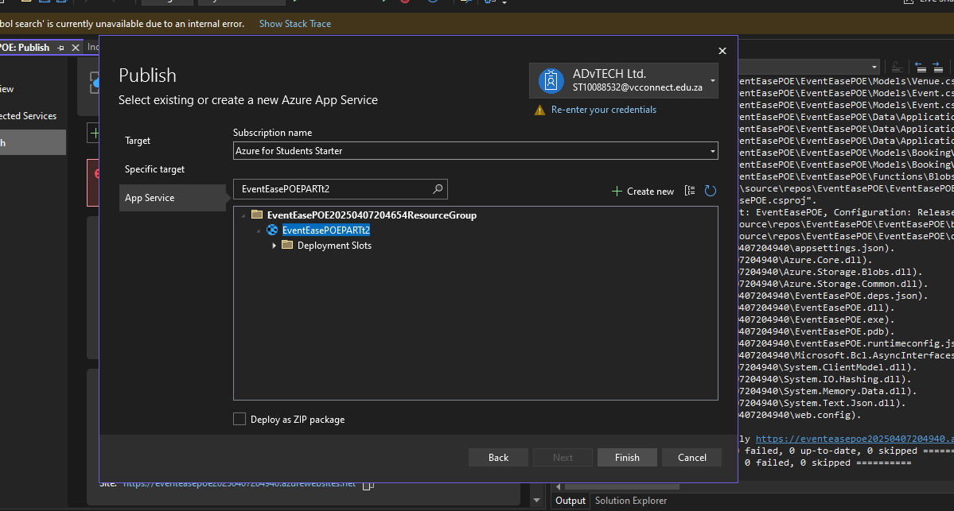

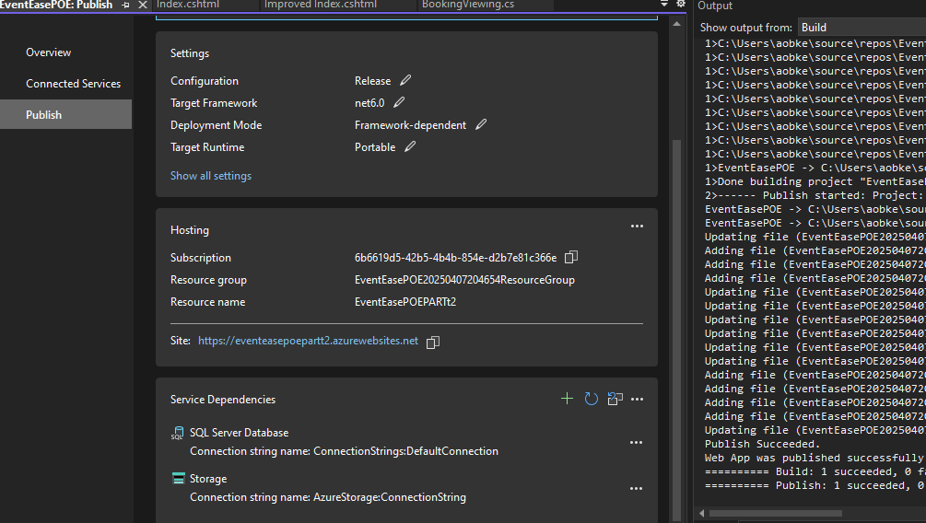

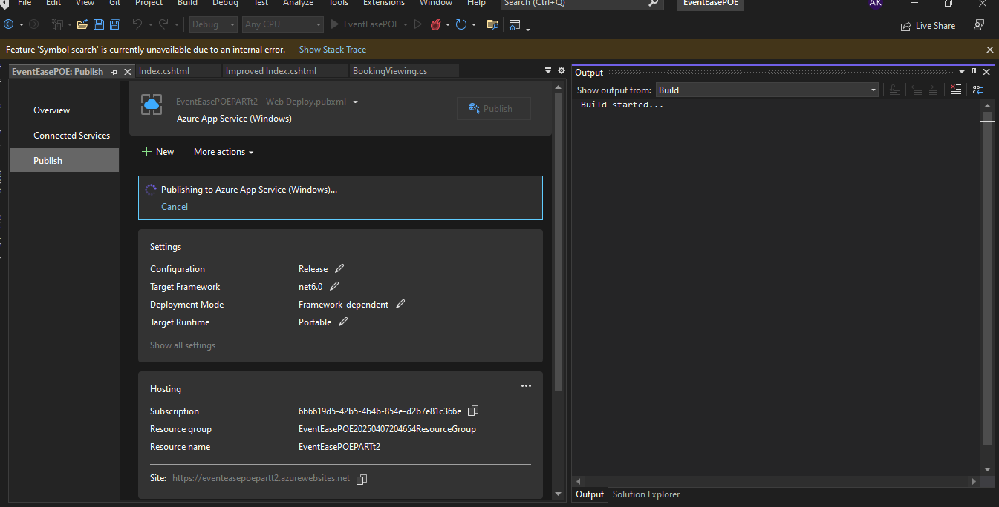

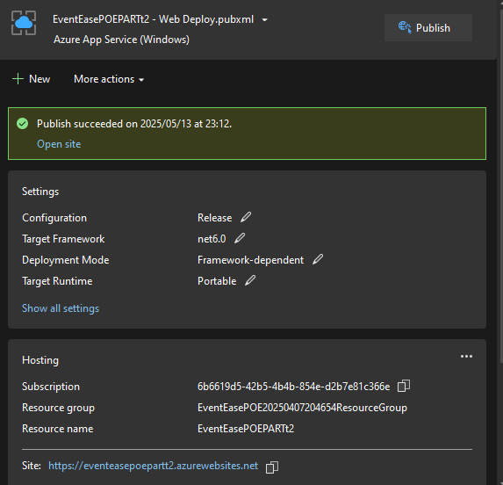

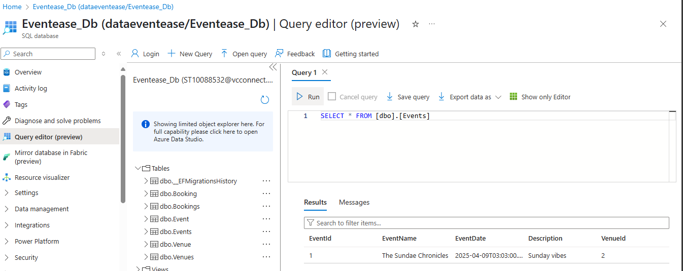

E. Database Design, Cognitive search

1. Azure cognitive search is a cloud-based search service from Microsoft that helps developers build and manage powerful search experiences. It allows users to index and query content from various sources, including websites, databases, and documents. (HeidiSteen, 2025) (Brush, 2023) Traditional search engines, like Google, Bing, and Yahoo, rely on indexing and ranking algorithms to deliver search results. They crawl the web, index content, and then use algorithms to match user queries with relevant information. These engines excel at finding specific web pages or documents based on keyword matching and offer features like advanced query syntax and filters. (Kerner, 2024) The system strongly excels in understanding the sophisticated queries, contextually recommending, and ranking results based on true relevance against the actual query instead of inflating counts of keyword matches.

2. “This process makes your database simpler to navigate while also enhancing the precision and integrity of your data. Data normalization ensures that all of the records in the database of customers have the same appearance, readability, and usability.” By reducing data redundancy, minimizing cloud storage costs and improving elastic scaling capabilities.

The impact on normalised structures, it is organizing your data so you don't repeat the same information everywhere. Instead of having customer names in every order record, you store them once and reference them. It is important because normalized data is much easier to manage across multiple servers when it comes to scaling issues and It keeps cloud data consistent.

The impact on denormalised structures, Combining of data from multiple different tables is done for optimizing data retrieval into one single table or document. It reads faster because joining is less necessary.

Data that is readily available in just a single table simplifies any queries.

Updates become more complex with potentially wasting storage space also data redundancy increases. It can compromise data, if one does not manage it carefully. Data's careful management is important for its integrity. (Kordos, 2024)

URL Links:

GITHUB: https://github.com/ST10088532/VCSANDTON-CLDV6211-POE-PART2.git

Azure published link: https://eventeasepoepartt2.azurewebsites.net

# Part 3

## Updated codebases and files/functionality

**Blob storage:**

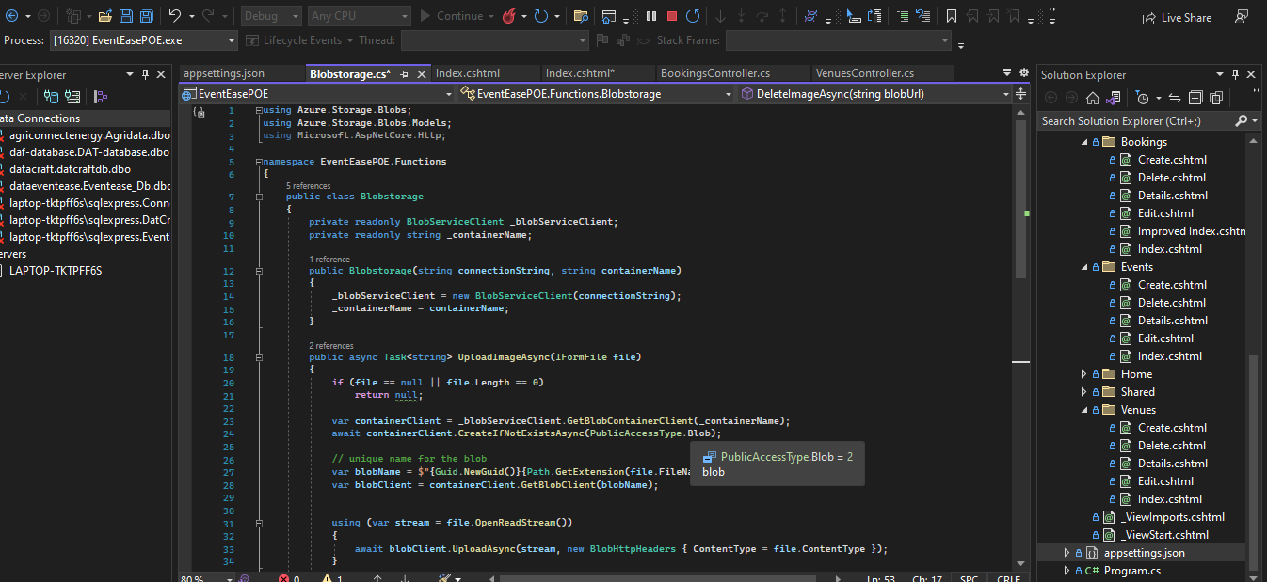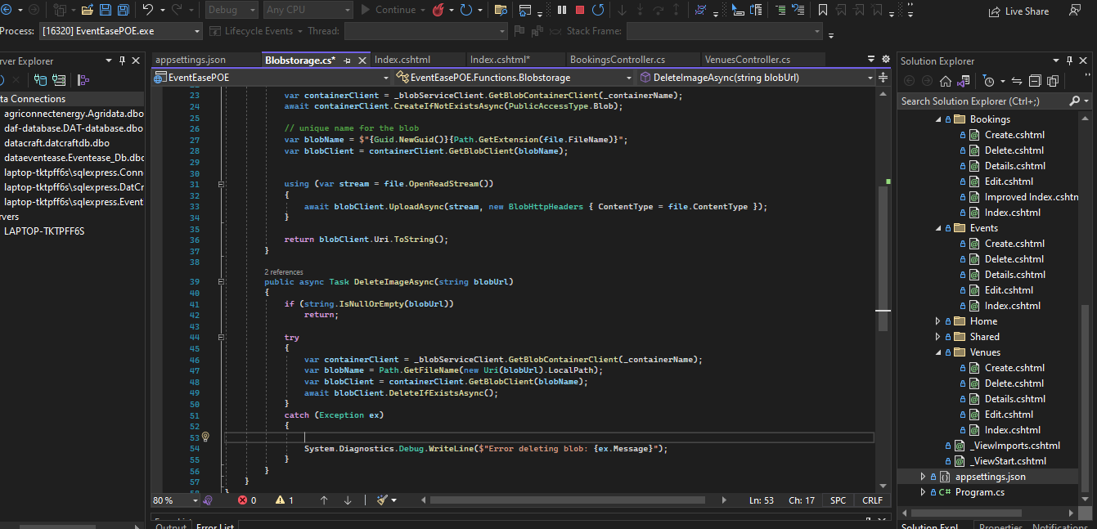

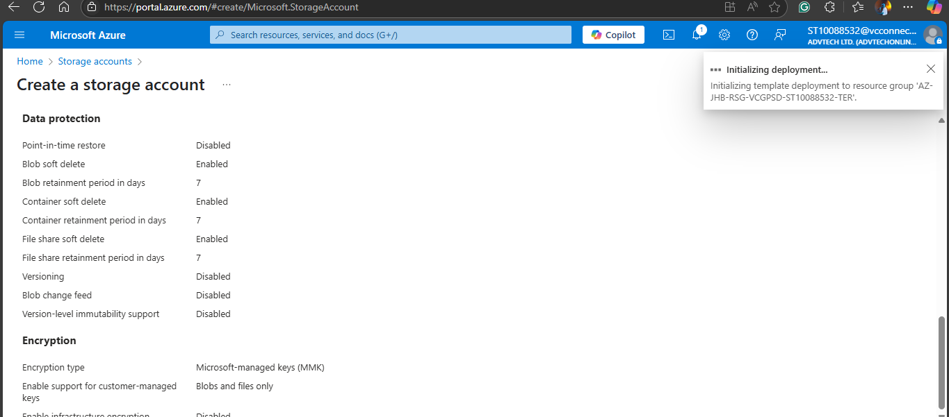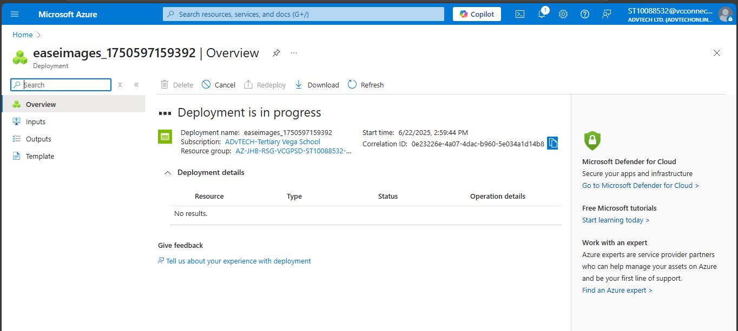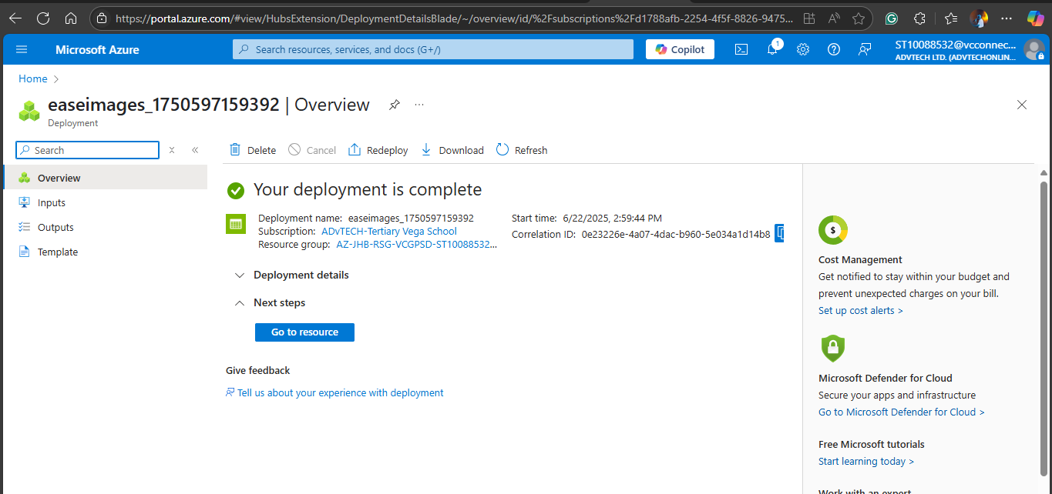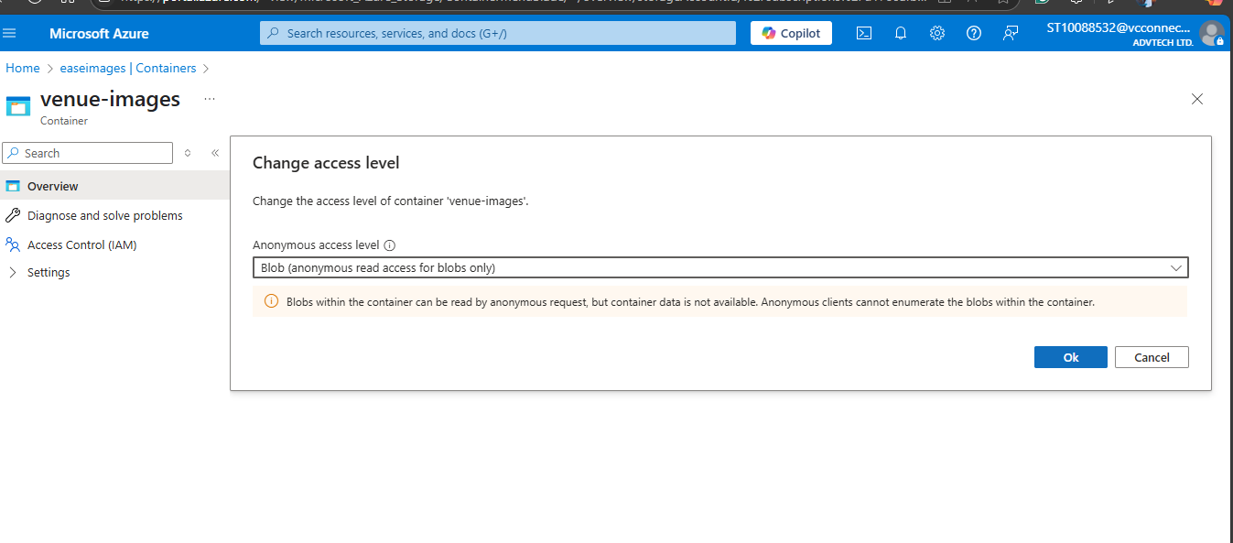

**Booking View and Search? Enhanced Display and Search**

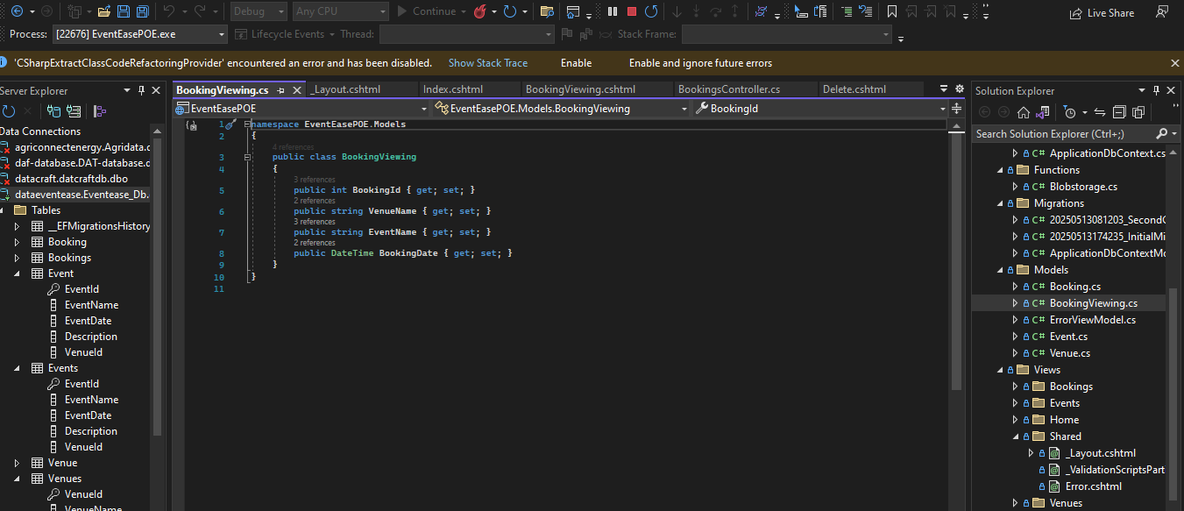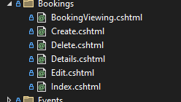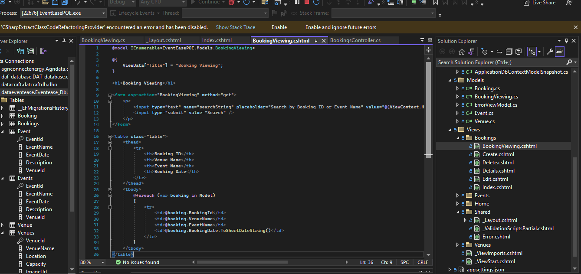

1. 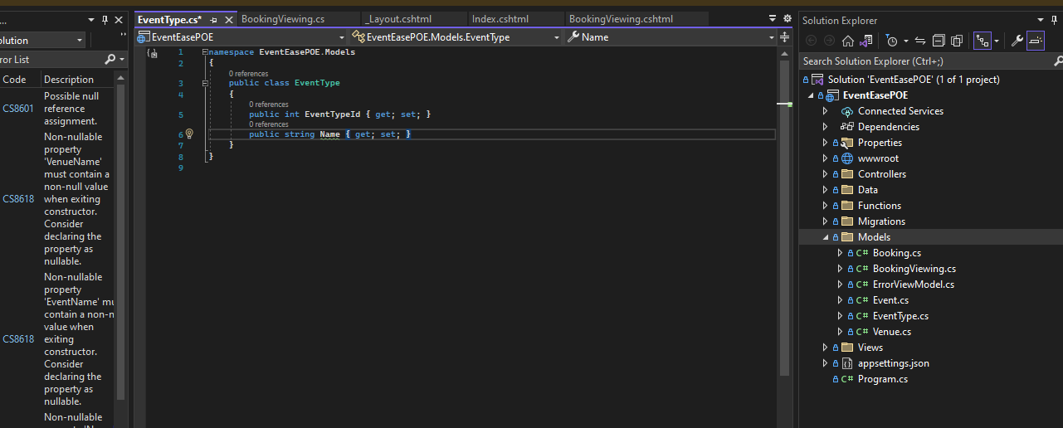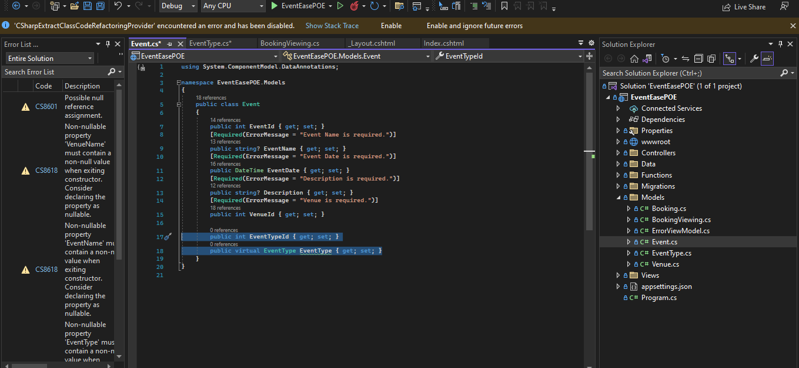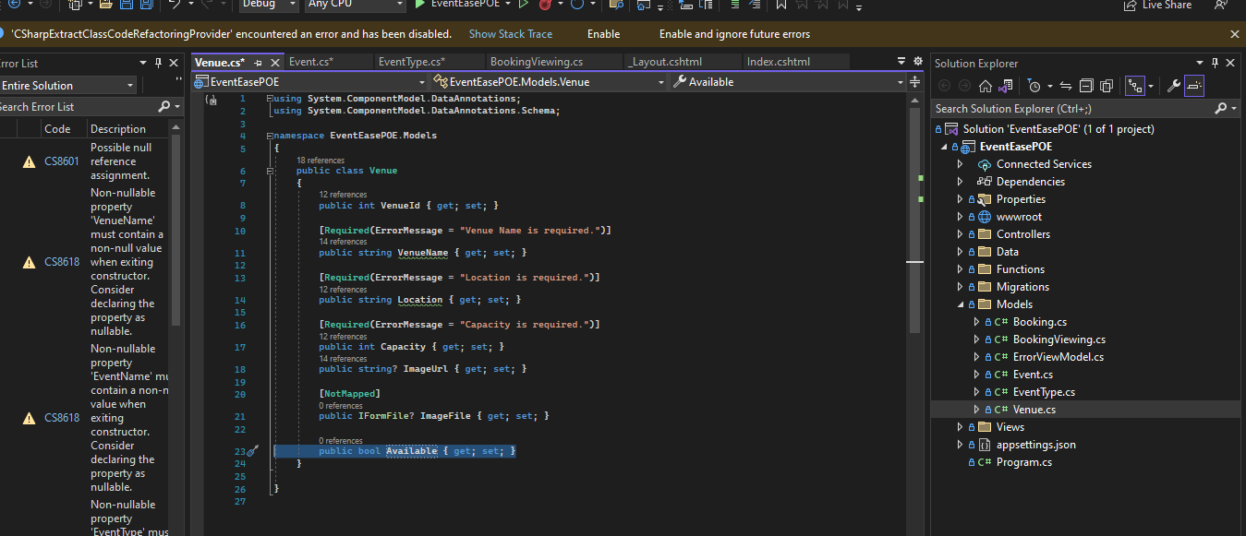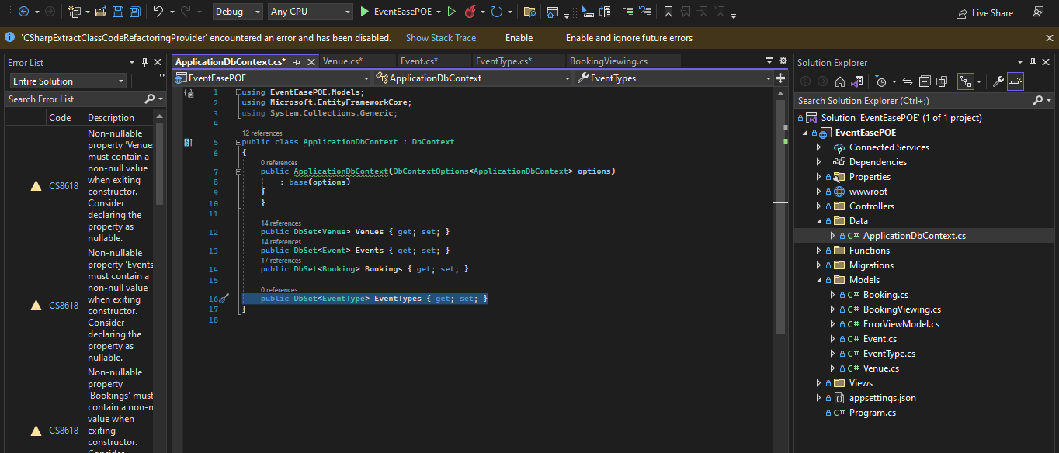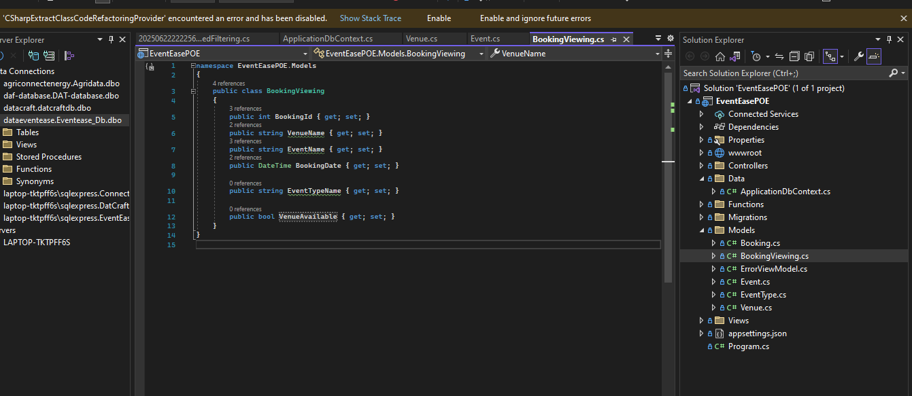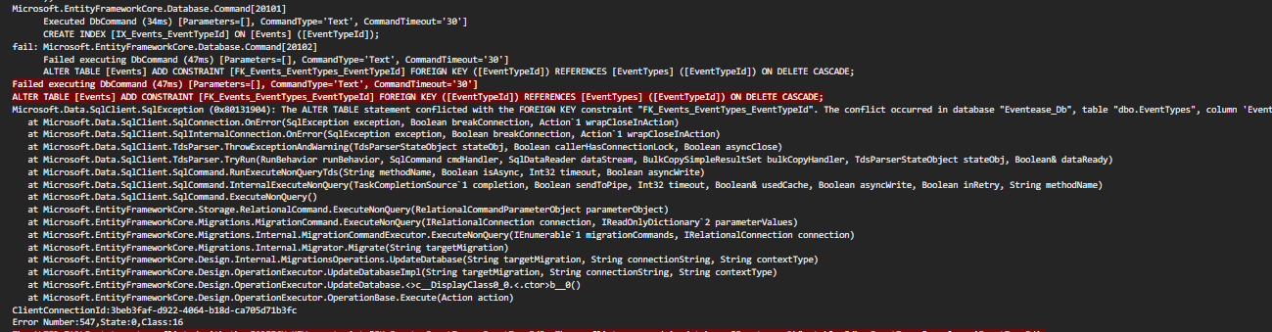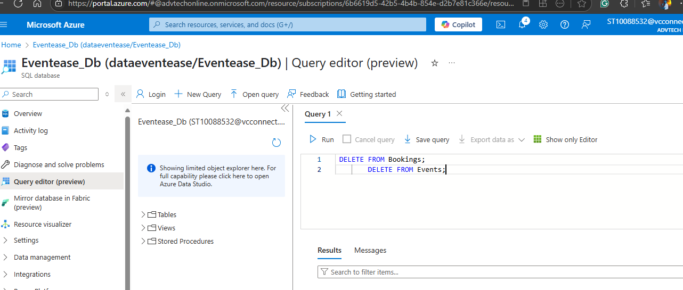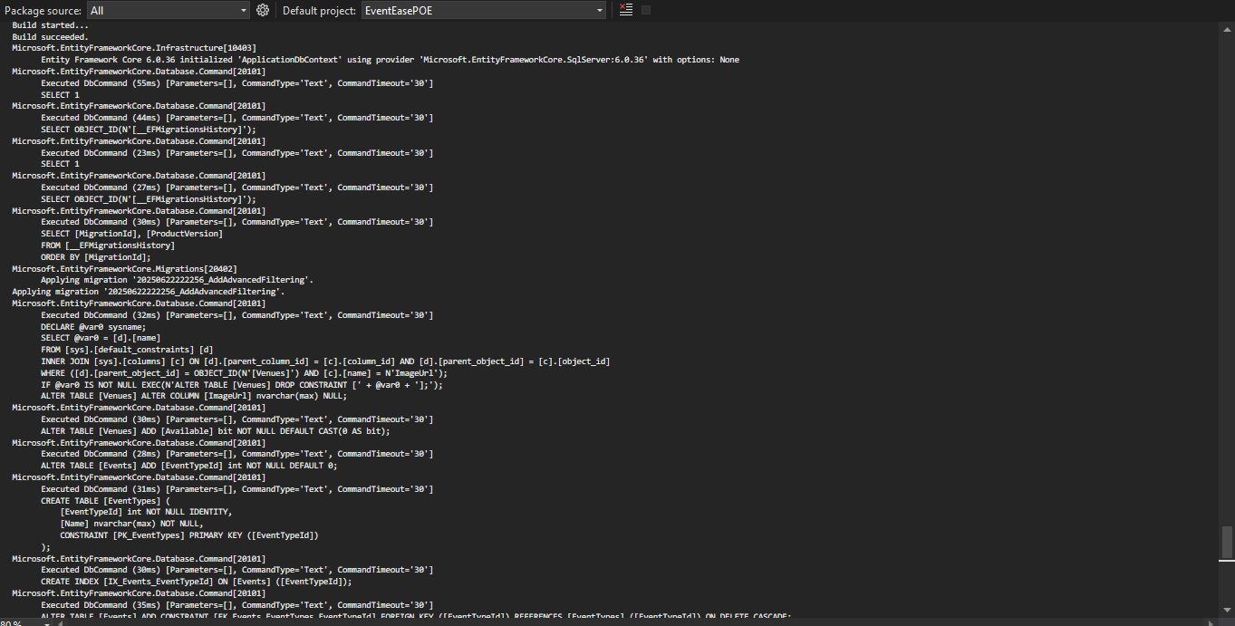

Venues page:

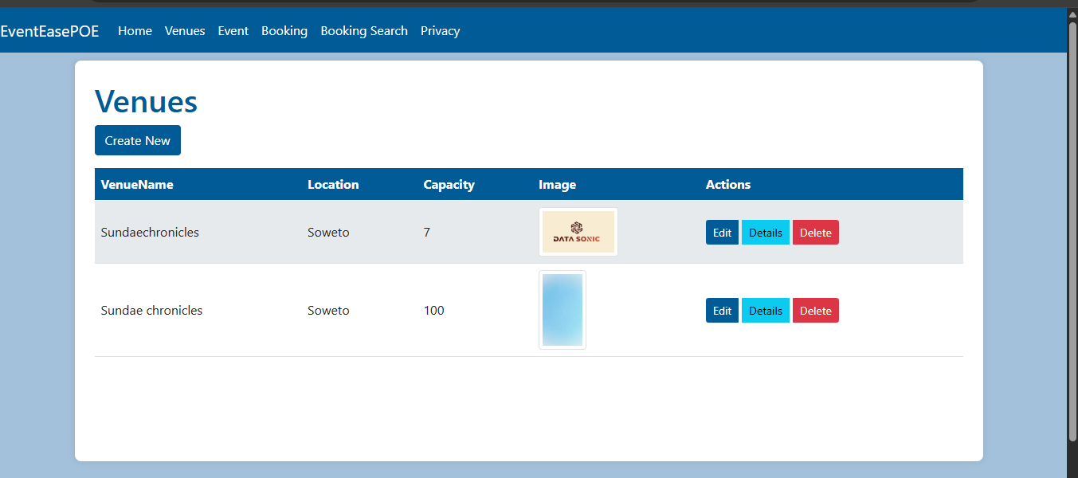

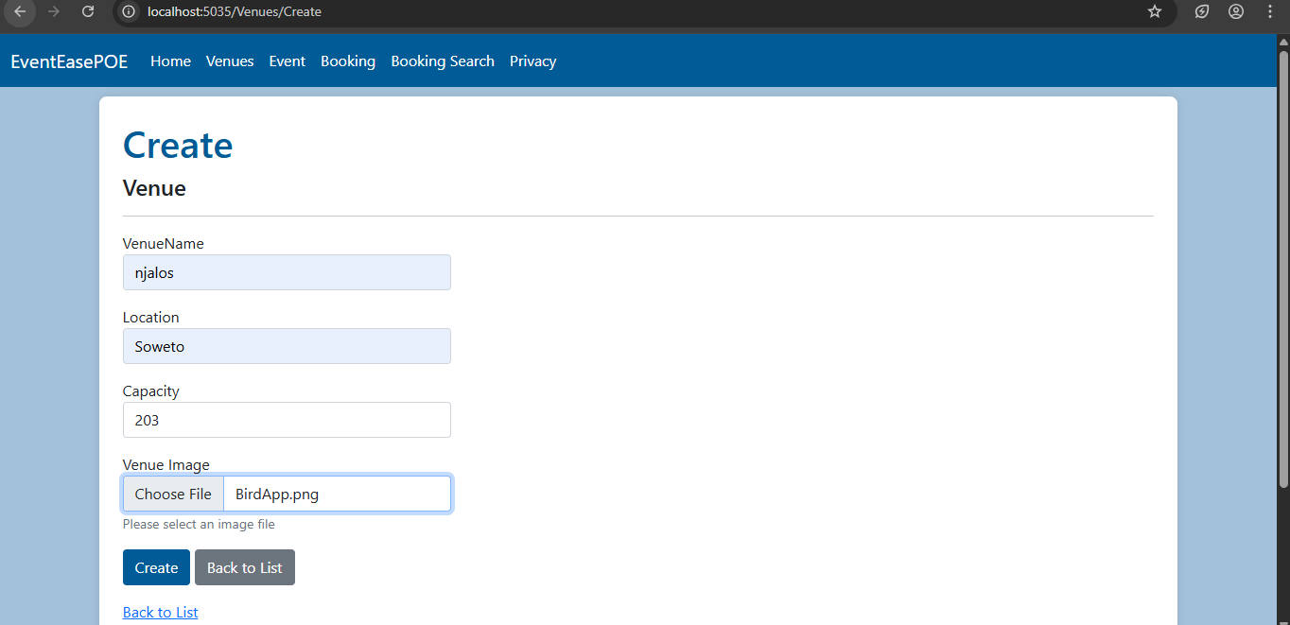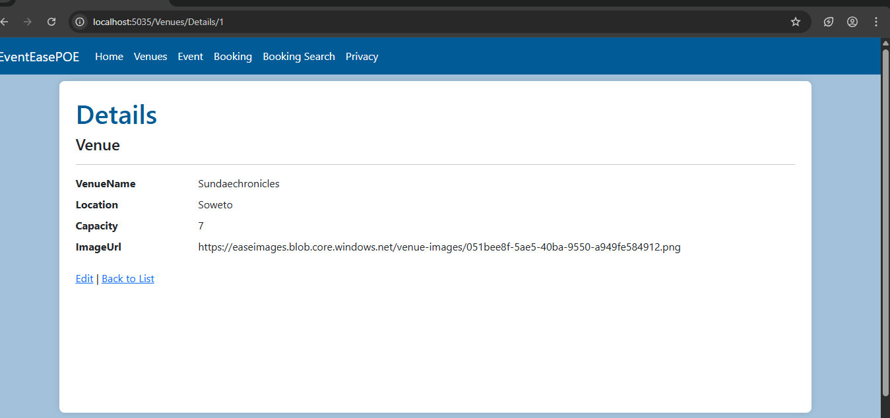

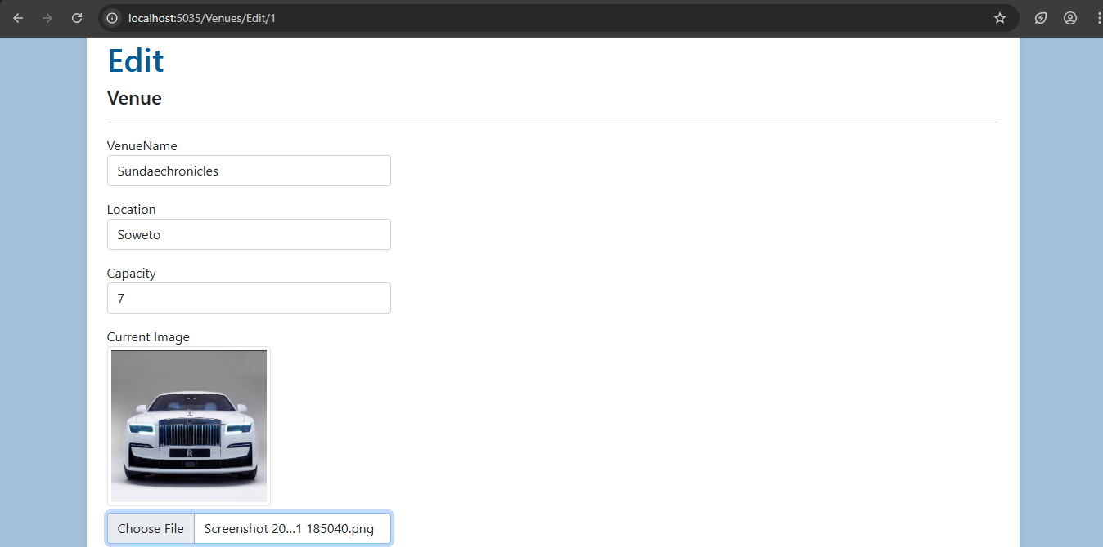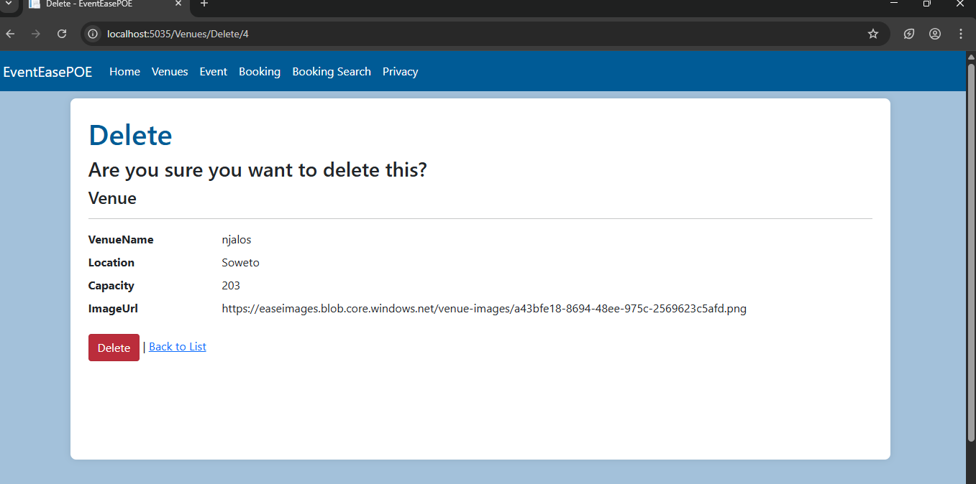

Events page

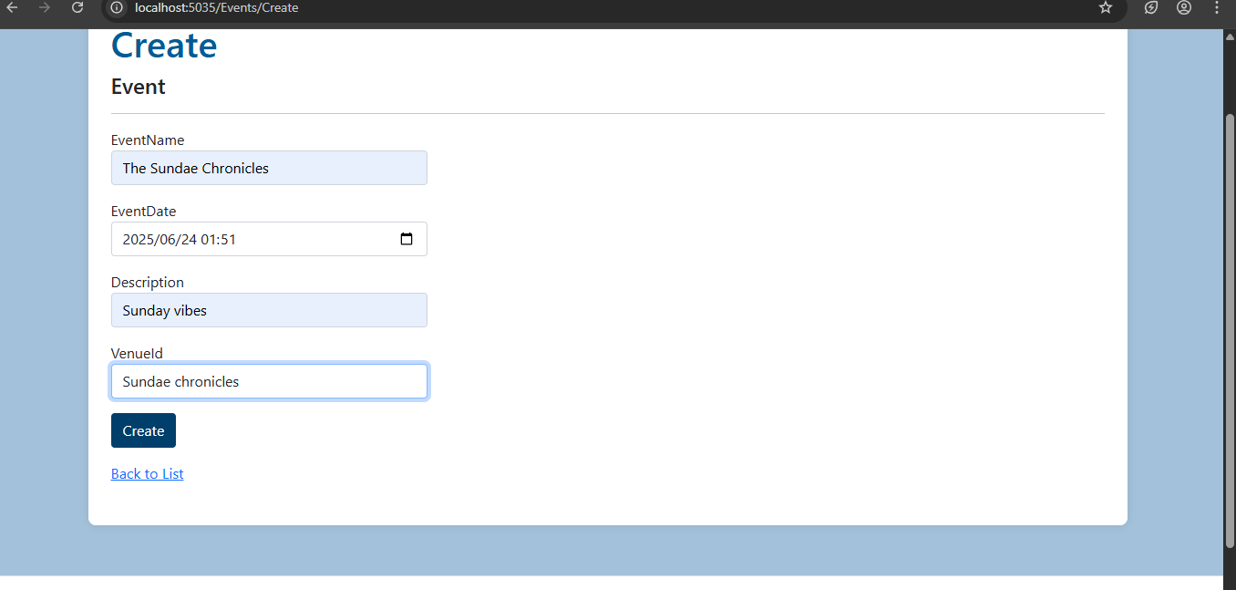

Advanced search/Filter Search

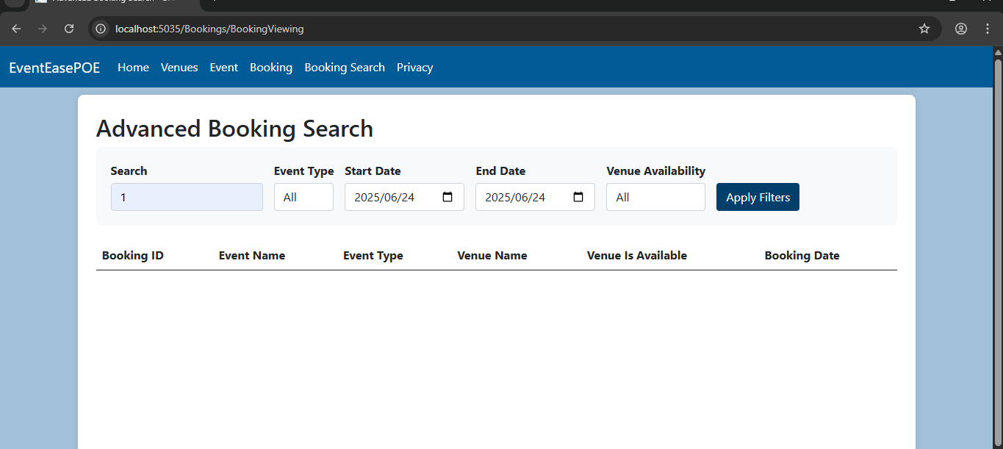

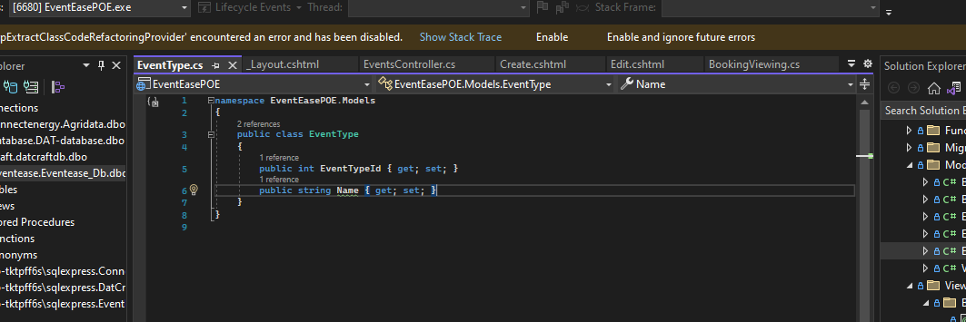

B.

Web App URL:

<https://st10088532eventeasepoe.azurewebsites.net>

GITHUB link: https://github.com/ST10088532/VCSTDN.git

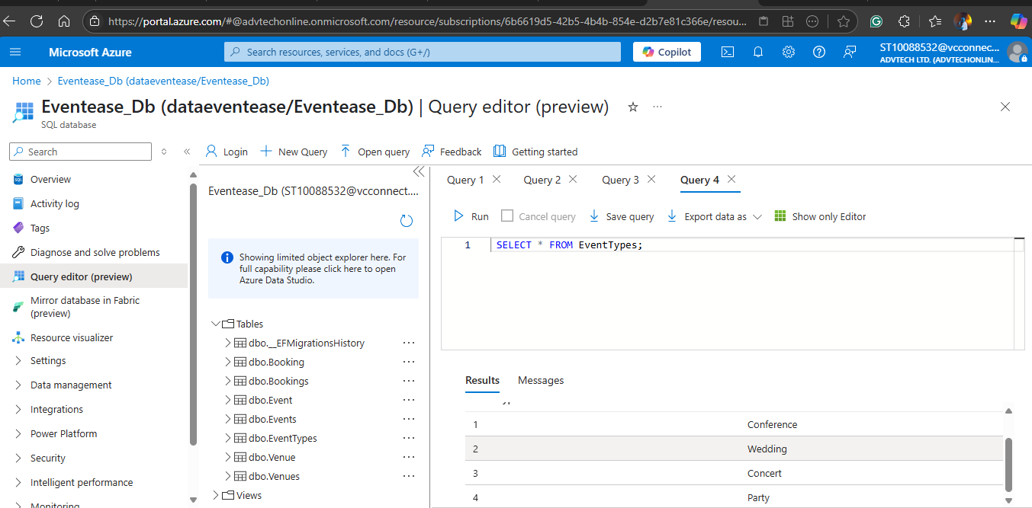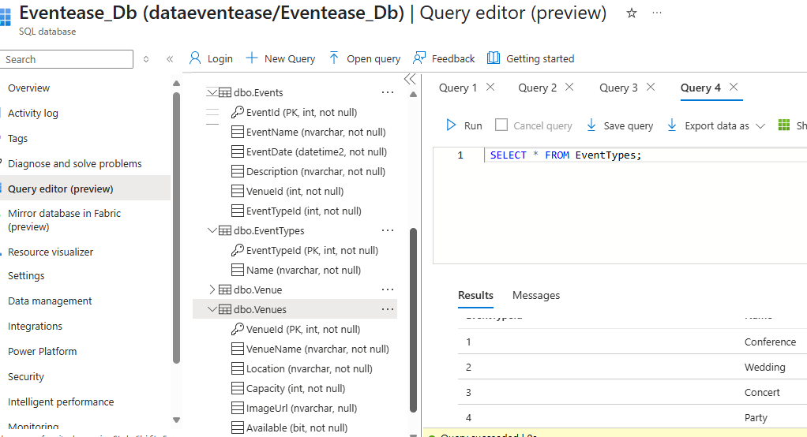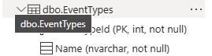

Final Deployment: 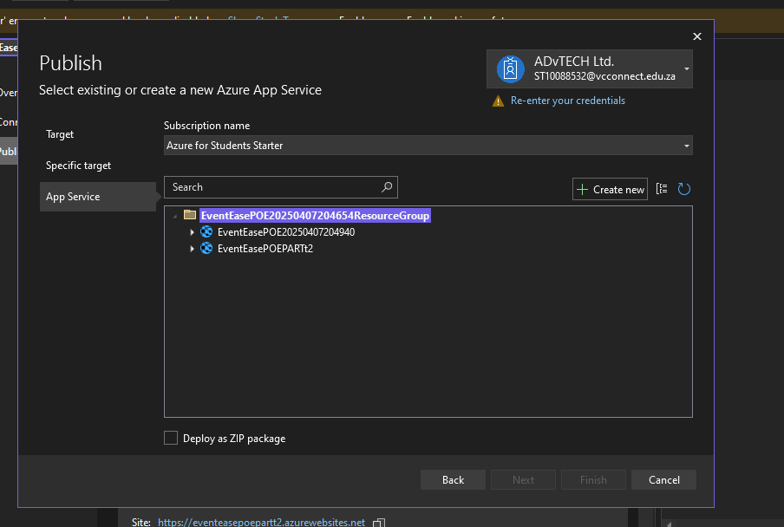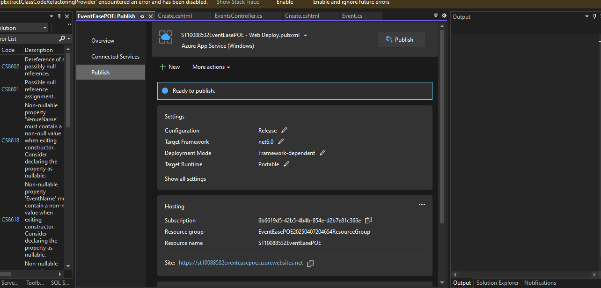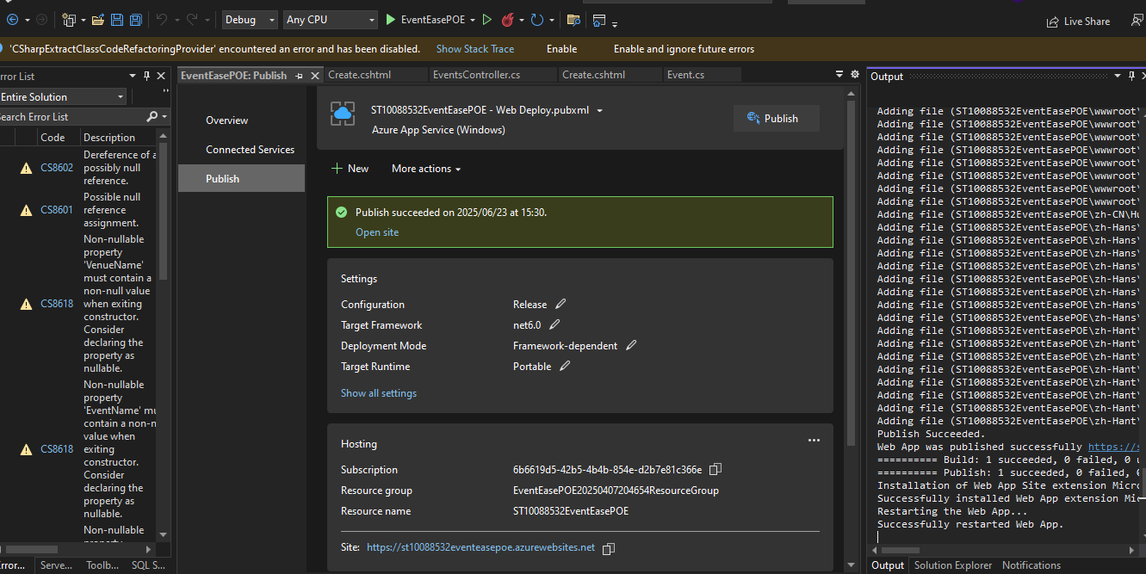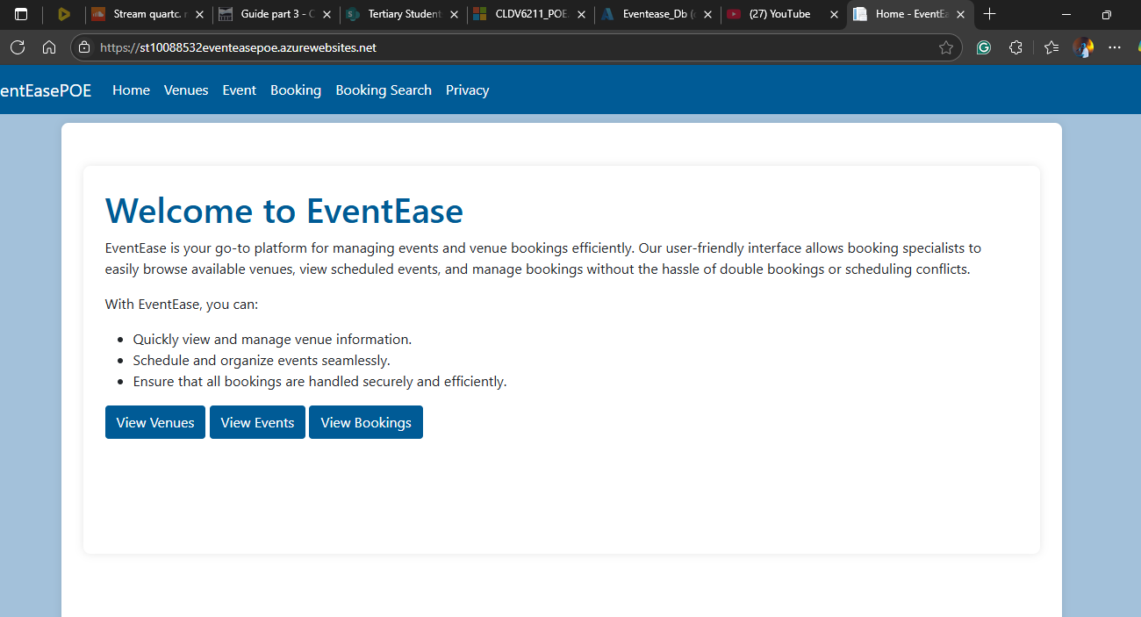

C.

Reflective Technical Report

Introduction

This report will demonstrate and describe my development path during the POE which has been/was a web application for managing venues, events, and bookings. The web application takes advantage of Azure services, such as: Azure Web App, Azure SQL Database, and Azure Blob Storage. This report is a brief account of the time I spent on these services, the technical and architectural/UI decisions that I took and the lessons learnt in designing, developing and deploying a cloud based application.

System feature list:

Comprehensive List of Features and Requirements

Azure Web App - The EventEasePOE ASP. NET MVC application in an elastic, managed web environment.

Azure SQL Database - Contains all tabular data such as venues, events, bookings, and event type data with integrity, security, and high availability.

Azure Blob Storage - Twitter metadata in JSON format processed and served; unstructured data stored at scale in an efficient and secure manner.

Venue Management - CRUD operations for Venues with Image upload and delete into Blob Storage not allowing a delete when the there are active bookings on the Venue.

Event Management – CRUD operations for events which are related with venues and event types, also doesn’t allow double booking of venues for same date time.

Manage Booking - CRUD for bookings (with double-booking protection, and heavy validation)

Search and Filter - Search Bookings by Booking ID or Event Name and filter by event type, venue availability and date range.

Validation and Exception Management- Performed server side and client-side validation using data annotations, error message and validation summaries.

Optimized Display – Provides an all -in-one view of booking, event, and venue details using intuitive navigation tabs.

Brief Explanation of How Each Feature/Requirement Works

Azure Web App:

The app is deployed to Azure App Service and is publicly accessible via a URL. This service takes care of scaling, patching and load balancing out of the box.

Azure SQL Database:

Azure SQL is used for all of the application data. ORM, migrations, and data access done using Entity Framework Core. The database ensures referential integrity and enables concurrent access.

Azure Blob Storage:

Venue images are uploaded from web app and saved in Azure Blob Storage. Images are loaded using URLs in the app, and also removed when venues are unlisted.

Local event hosting and coordination.

Users can manage the venues, events, and bookings (CRUD). Business rules (e.g. no double-bookings or no-deletion with active booking) are enforced in the controllers.

Filtering and Search:

Tribe members can search and narrow down bookings and events by way of a variety of filters, making it all the more user-friendly and convenient!

Validation/Error Handling:

Data annotations make certain that the required fields are filled in. The validation errors show up in the user interface and server side checks keep invalid operations out of the application.

Enhanced Display:

Views are used to display linked data (Bookings display event and venue details), to enhance user interaction.

**Technologies Used and Why**

1.ASP.NET Core MVC

• Why: Offers a good architecture to design web applications which are scalable as well as maintainable with clear separation of concerns.

• Alternative: Node.js/Express, Django or Ruby on Rails.

2.Entity Framework Core

• Why: Eases the data access and migration tasks, supports LINQ queries, and has a good integration with Azure SQL.

• Alternative: Dapper, ADO.NET or NHibernate.

3.Bootstrap

• Why: With very minimal effort, allows the creation of modern user interfaces that are responsive and align with contemporary design standards.

• Alternative: Tailwind CSS, Materialize or custom made CSS.

**Alternative Components Discussion**

Web Hosting:

Instead of Azure App Service, AWS Elastic Beanstalk or Google App Engine could provide similar managed hosting. On-premises IIS is an option but lacks cloud scalability.

Database:

Azure Table Storage or Cosmos DB could be used for NoSQL scenarios, but lack relational features needed for this app. AWS RDS or Google Cloud SQL are also alternatives.

Storage:

Amazon S3 or Google Cloud Storage offer similar blob storage capabilities. Local file storage is possible but not scalable or cloud-friendly. (Anon., n.d.)

**Self-reflection:**

The Poe went okay in my view, it had a consistent flow with the questions asked and the tasks that were needed to do in order to complete the project.

Part 1 was good, with the mixture of practical work and theory it set a good starting point for the projects needs and understanding, testing our knowledge and understanding in both ways.

Part 2 of the POE was a bit more challenging, as it need more functionality for the web app. Personally I found the azure database connection and configuration trickier than the coding because my azure account kept giving me issues which caused my web app to not function the way it is supposed to which also caused some delay in finalising my submission. The final part is a bit more easier in terms of work load, but needs concentration and time in order to complete which I like. What I learnt form the project is time management and how to build a web application and use azure cloud services. Designing for the cloud means considering security, cost, and performance from the start. I understand the value of using managed services. This project has prepared me to architect, develop, and deploy robust cloud solutions using Azure and modern web technologies.

# Bibliography

Anon., n.d. *ChatGpt.* [Online]   
Available at: https://chatgpt.com/  
[Accessed 20 June 2025].

BillWagner, 2024. *Resolve errors and warnings related to assembly references.* [Online]   
Available at: https://learn.microsoft.com/en-us/dotnet/csharp/language-reference/compiler-messages/assembly-references?f1url=%3FappId%3Droslyn%26k%3Dk(CS0234)  
[Accessed 10 May 2025].

Brush, K., 2023. *cognitive search.* [Online]   
Available at: https://www.techtarget.com/searchenterpriseai/definition/cognitive-search  
[Accessed 10 May 2025].

HeidiSteen, e.-u. s.-a., 2025. *What's Azure AI Search?.* [Online]   
Available at: https://learn.microsoft.com/en-us/azure/search/search-what-is-azure-search  
[Accessed 10 May 2025].

Kerner, S. M., 2024. *https://www.techtarget.com/whatis/feature/GenAI-search-vs-traditional-search-engines-How-they-differ#:~:text=Traditional%20search%20engines%20help%20users,and%20brief%20description%20or%20snippet..* [Online]   
Available at: https://www.techtarget.com/whatis/feature/GenAI-search-vs-traditional-search-engines-How-they-differ#:~:text=Traditional%20search%20engines%20help%20users,and%20brief%20description%20or%20snippet.  
[Accessed 10 May 2025].

Kordos, A., 2024. *Normalization vs. Denormalization in databases.* [Online]   
Available at: https://codilime.com/blog/normalization-vs-denormalization-in-databases/  
[Accessed 10 May 2025].

Mrzyglod, K., 2022. *Azure for developers , Implement rich Azure Paas Ecosytems using containers, serverless services, and storage solutions.* 2nd ed. Birmingham: Packt Publishing Ltd..

Ron Karjian, Z. F., 2024. *On premises vs. cloud pros and cons, key differences.* [Online]   
Available at: https://www.techtarget.com/searchcloudcomputing/tip/Evaluate-on-premises-vs-cloud-computing-pros-and-cons  
[Accessed 01 April 2025].

S., N., n.d. *On-Premises vs Cloud: Key Differences, Pros & Cons.* [Online]   
Available at: https://www.cloudpanel.io/blog/on-premises-vs-cloud-computing/  
[Accessed 01 April 2025].